**Digital Signal Processing**

**Final Project**

**(Matlab)**

**Audio Equalizer**

***Made By:***

**Name:** Ahmed Wael Mohamed

**ID:** 6071

**Name:** Adel Ashraf Mohamed

**ID:** 6297

**Name:** Youssef Mohamed sabry

**ID:** 6239

***Report Contents***

1. Program Code.
2. The Analysis of each Filter Used.
3. Different Sample Runs

(FIR-IIR-Output signal after Modification)

1. Figures of Output in Time and Frequency Domains

**Program Code**

clc

clear

close all

delta = [1 zeros(1, 200)];

step = [1 ones(1, 200)];

% n sampling for impulse and step responses

n = 0:1:200;

% Audio file importing

global filename;

msg1 =( ' >>Audio Equalizer<< ' );

disp (msg1)

msg2 =( ' >>Please Select the audio file you want to edit<< ' );

disp (msg2)

[filename, pathname] = uigetfile({'*.wav';'*.*'},'File Selector');

% Getting filters' gains from the user

msg3 =( ' Enter the gain of each of the frequency bands ' );

disp (msg3)

g1 = input ( ' Gain of filter 0 - 170 Hz: ' );

g2 = input ( ' Gain of filter 170 - 310 Hz: ' );

g3 = input ( ' Gain of filter 310 - 600 Hz: ' );

g4 = input ( ' Gain of filter 600 - 1k Hz: ' );

g5 = input ( ' Gain of filter 1k - 3k Hz: ' );

g6 = input ( ' Gain of filter 3k - 6k Hz: ' );

g7 = input ( ' Gain of filter 6k - 12k Hz: ' );

g8 = input ( ' Gain of filter 12k - 14k Hz: ' );

g9 = input ( ' Gain of filter 14k - 16k Hz: ' );

% Read the audio file and get its sampling frequency

[y, F] = audioread(filename);

% Order of IIR = 4 and that of FIR = 40

N = 4;

Nf = 40;

% The value of normalized frequency

fn = F/2;

% Filter #1 (0 - 170 Hz)

% IIR

[numerator1, denomenator1] = butter(N, 170/fn);

[H1, w1] = freqz(numerator1, denomenator1);

magnitude1 = abs(H1);

phase1 = angle(H1) * (180/pi);

figure

plot(w1/pi, magnitude1);

title('IIR Magnitude Response 0 - 170 Hz');

figure

plot(w1/pi, phase1);

title('IIR Phase Response 0 - 170 Hz');

impulseResponse1 = filter(numerator1, denomenator1, delta);

figure

plot(n,impulseResponse1);

title('IIR Impulse Response 0 - 170 Hz');

stepResponse1 = filter(numerator1, denomenator1, step);

figure

plot(n,stepResponse1);

title('IIR Step Response 0 - 170 Hz');

figure

zplane(roots(numerator1), roots(denomenator1));

title('IIR Poles and Zeros 0 - 170 Hz');

% Part #1 of composite signal from IIR filter

y1 = (10.^((g1)/20))*filter(numerator1, denomenator1, y);

% FIR

coef1=fir1(Nf,170/fn);

[Hf1,wf1]=freqz(coef1,1);

figure

plot(wf1/pi, abs(Hf1));

title('FIR Magnitude Response 0 - 170 Hz');

figure

plot(wf1/pi, angle(Hf1)*(180/pi));

title('FIR Phase Response 0 - 170 Hz');

impulseResponsef1 = filter(coef1,1, delta);

figure

plot(n, impulseResponsef1);

title('FIR Impulse Response 0 - 170 Hz');

stepResponsef1 = filter(coef1,1, step);

figure

plot(n, stepResponsef1);

title('FIR Step Response 0 - 170 Hz');

figure

zplane(roots(coef1));

title('FIR Poles and Zeros 0 - 170 Hz');

% Part #1 of composite signal from FIR filter

yf1 = (10.^((g1)/20))*filter(coef1, 1, y);

% Filter #2 (170 - 310 Hz)

%IIR

wc2 = [170/fn 310/fn];

[numerator2, denomenator2] = butter(N, wc2);

[H2, w2] = freqz(numerator2, denomenator2);

magnitude2 = abs(H2);

phase2 = angle(H2) * (180/pi);

figure

plot(w2/pi, magnitude2);

title('IIR Magnitude Response 170 - 310 Hz');

figure

plot(w2/pi, phase2);

title('IIR Phase Response 170 - 310 Hz');

impulseResponse2 = filter(numerator2, denomenator2, delta);

figure

plot(n, impulseResponse2);

title('IIR Impulse Respponse 170 - 310 Hz');

stepResponse2 = filter(numerator2, denomenator2, step);

figure

plot(n, stepResponse2);

title('IIR Step Response 170 - 310 Hz');

figure

zplane(roots(numerator2), roots(denomenator2));

title('IIR Poles and Zeros 170 - 310 Hz');

% Part #2 of composite signal from IIR filter

y2 = (10.^((g2)/20))*filter(numerator2, denomenator2, y);

% FIR

coef2=fir1(Nf,wc2);

[Hf2,wf2]=freqz(coef2,1);

figure

plot(wf2/pi, abs(Hf2));

title('FIR Magnitude Response 170 - 310 Hz');

figure

plot(wf2/pi, angle(Hf2)*(180/pi));

title('FIR Phase Response 170 - 310 Hz');

impulseResponsef2 = filter(coef2,1, delta);

figure

plot(n, impulseResponsef2);

title('FIR Impulse Respponse 170 - 310 Hz');

stepResponsef2 = filter(coef2,1, step);

figure

plot(n, stepResponsef2);

title('FIR Step Response 170 - 310 Hz');

figure

zplane(roots(coef2));

title('FIR Poles and Zeros 170 - 310 Hz');

% Part #2 of composite signal from FIR filter

yf2 = (10.^((g2)/20))*filter(coef2, 1, y);

% Filter #3 (310 - 600 Hz)

% IIR

wc3 = [310/fn 600/fn];

[numerator3, denomenator3] = butter(N, wc3);

[H3, w3] = freqz(numerator3, denomenator3);

magnitude3 = abs(H3);

phase3 = angle(H3) * (180/pi);

figure

plot(w3/pi, magnitude3);

title('IIR Magnitude Response 310 - 600 Hz');

figure

plot(w3/pi, phase3);

title('IIR Phase Response 310 - 600 Hz');

impulseResponse3 = filter(numerator3, denomenator3, delta);

figure

plot(n, impulseResponse3);

title('IIR Impulse Response 310 - 600 Hz');

stepResponse3 = filter(numerator3, denomenator3, step);

figure

plot(n, stepResponse3);

title('IIR Step Response 310 - 600 Hz');

figure

zplane(roots(numerator3), roots(denomenator3));

title('IIR Poles and Zeros 310 - 600 Hz');

% Part #3 of composite signal from IIR filter

y3 = (10.^((g3)/20))*filter(numerator3, denomenator3, y);

% FIR

coef3=fir1(Nf,wc3);

[Hf3,wf3]=freqz(coef3,1);

figure

plot(wf3/pi, abs(Hf3));

title('FIR Magnitude Response 310 - 600 Hz');

figure

plot(wf3/pi, angle(Hf3)*(180/pi));

title('FIR Phase Response 310 - 600 Hz');

impulseResponsef3 = filter(coef3,1, delta);

figure

plot(n, impulseResponsef3);

title('FIR Impulse Response 310 - 600 Hz');

stepResponsef3 = filter(coef3,1, step);

figure

plot(n, stepResponsef3);

title('FIR Step Response 310 - 600 Hz');

figure

zplane(roots(coef3));

title('FIR Poles and Zeros 310 - 600 Hz');

% Part #3 of composite signal from FIR filter

yf3 = (10.^((g3)/20))*filter(coef3, 1, y);

% Filter #4 (600 - 1K Hz)

% IIR

wc4 = [600/fn 1000/fn];

[numerator4, denomenator4] = butter(N, wc4);

[H4, w4] = freqz(numerator4, denomenator4);

magnitude4 = abs(H4);

phase4 = angle(H4) * (180/pi);

figure

plot(w4/pi, magnitude4);

title('IIR Magnitude Response 600 - 1000 Hz');

figure

plot(w4/pi, phase4);

title('IIR Phase Response 600 - 1000 Hz');

impulseResponse4 = filter(numerator4, denomenator4, delta);

figure

plot(n, impulseResponse4);

title('IIR Impulse Response 600 - 1000 Hz');

stepResponse4 = filter(numerator4, denomenator4, step);

figure

plot(n, stepResponse4);

title('IIR Step Response 600 - 1000 Hz');

figure

zplane(roots(numerator4), roots(denomenator4));

title('IIR Poles and Zeros 600 - 1000 Hz');

% Part #4 of composite signal from IIR filter

y4 = (10.^((g4)/20))*filter(numerator4, denomenator4, y);

% FIR

coef4=fir1(Nf,wc4);

[Hf4,wf4]=freqz(coef4,1);

figure

plot(wf4/pi, abs(Hf4));

title('FIR Magnitude Response 600 - 1000 Hz');

figure

plot(wf4/pi, angle(Hf4)*(180/pi));

title('FIR Phase Response 600 - 1000 Hz');

impulseResponsef4 = filter(coef4,1, delta);

figure

plot(n, impulseResponsef4);

title('FIR Impulse Response 600 - 1000 Hz');

stepResponsef4 = filter(coef4,1, step);

figure

plot(n, stepResponsef4);

title('FIR Step Response 600 - 1000 Hz');

figure

zplane(roots(coef4));

title('FIR Poles and Zeros 600 - 1000 Hz');

% Part #4 of composite signal from FIR filter

yf4 = (10.^((g4)/20))*filter(coef4, 1, y);

% Filter #5 (1K - 3K Hz)

% IIR

wc5 = [1000/fn 3000/fn];

[numerator5, denomenator5] = butter(N, wc5);

[H5, w5] = freqz(numerator5, denomenator5);

magnitude5 = abs(H5);

phase5 = angle(H5) * (180/pi);

figure

plot(w5/pi, magnitude5);

title('IIR Magnitude Response 1000 - 3000 Hz');

figure

plot(w5/pi, phase5);

title('IIR Phase Response 1000 - 3000 Hz');

impulseResponse5 = filter(numerator5, denomenator5, delta);

figure

plot(n, impulseResponse5)

title('IIR Impulse Response 1000 - 3000 Hz');

stepResponse5 = filter(numerator5, denomenator5, step);

figure

plot(n, stepResponse5);

title('IIR Step Response 1000 - 3000 Hz');

figure

zplane(roots(numerator5), roots(denomenator5));

title('IIR Poles and Zeros 1000 - 3000 Hz');

% Part #5 of composite signal from IIR filter

y5 = (10.^((g5)/20))*filter(numerator5, denomenator5, y);

% FIR

coef5=fir1(Nf,wc5);

[Hf5,wf5]=freqz(coef5,1);

figure

plot(wf5/pi, abs(Hf5));

title('FIR Magnitude Response 1000 - 3000 Hz');

figure

plot(wf5/pi, angle(Hf5)*(180/pi));

title('FIR Phase Response 1000 - 3000 Hz');

impulseResponsef5 = filter(coef5,1, delta);

figure

plot(n, impulseResponsef5);

title('FIR Impulse Response 1000 - 3000 Hz');

stepResponsef5 = filter(coef5,1, step);

figure

plot(n, stepResponsef5);

title('FIR Step Response 1000 - 3000 Hz');

figure

zplane(roots(coef5));

title('FIR Poles and Zeros 1000 - 3000 Hz');

% Part #5 of composite signal from FIR filter

yf5 = (10.^((g5)/20))*filter(coef5, 1, y);

% Filter #6 (3K - 6K Hz)

% IIR

wc6 = [3000/fn 6000/fn];

[numerator6, denomenator6] = butter(N, wc6);

[H6, w6] = freqz(numerator6, denomenator6);

magnitude6 = abs(H6);

phase6 = angle(H6) * (180/pi);

figure

plot(w6/pi, magnitude6);

title('IIR Magnitude Response 3000 - 6000 Hz');

figure

plot(w6/pi, phase6);

title('IIR Phase Response 3000 - 6000 Hz');

impulseResponse6 = filter(numerator6, denomenator6, delta);

figure

plot(n, impulseResponse6);

title('IIR Impulse Response 3000 - 6000 Hz');

stepResponse6 = filter(numerator6, denomenator6, step);

figure

plot(n, stepResponse6);

title('IIR Step Response 3000 - 6000 Hz');

figure

zplane(roots(numerator6), roots(denomenator6));

title('IIR Poles and Zeros 3000 - 6000 Hz');

% Part #6 of composite signal from IIR filter

y6 = (10.^((g6)/20))*filter(numerator6, denomenator6, y);

% FIR

coef6=fir1(Nf,wc6);

[Hf6,wf6]=freqz(coef6,1);

figure

plot(wf6/pi, abs(Hf6));

title('FIR Magnitude Response 3000 - 6000 Hz');

figure

plot(wf6/pi, angle(Hf6)*(180/pi));

title('FIR Phase Response 3000 - 6000 Hz');

impulseResponsef6 = filter(coef6,1, delta);

figure

plot(n, impulseResponsef6);

title('FIR Impulse Response 3000 - 6000 Hz');

stepResponsef6 = filter(coef6,1, step);

figure

plot(n, stepResponsef6);

title('FIR Step Response 3000 - 6000 Hz');

figure

zplane(roots(coef6));

title('FIR Poles and Zeros 3000 - 6000 Hz');

% Part #6 of composite signal from FIR filter

yf6 = (10.^((g6)/20))*filter(coef6, 1, y);

%Filter #7 (6K - 12K Hz)

% IIR

wc7 = [6000/fn 12000/fn];

[numerator7, denomenator7] = butter(N, wc7);

[H7, w7] = freqz(numerator7, denomenator7);

magnitude7 = abs(H7);

phase7 = angle(H7) * (180/pi);

figure

plot(w7/pi, magnitude7);

title('IIR Magnitude Response 6000 - 12000 Hz');

figure

plot(w7/pi, phase7);

title('IIR Phase Response 6000 - 12000 Hz');

impulseResponse7 = filter(numerator7, denomenator7, delta);

figure

plot(n, impulseResponse7);

title('IIR Impulse Response 6000 - 12000 Hz');

stepResponse7 = filter(numerator7, denomenator7, step);

figure

plot(n, stepResponse7);

title('IIR Step Response 6000 - 12000 Hz');

figure

zplane(roots(numerator7), roots(denomenator7));

title('IIR Poles and Zeros 6000 - 12000 Hz');

% Part #7 of composite signal from IIR filter

y7 = (10.^((g7)/20))*filter(numerator7, denomenator7, y);

% FIR

coef7=fir1(Nf,wc7);

[Hf7,wf7]=freqz(coef7,1);

figure

plot(wf7/pi, abs(Hf7));

title('FIR Magnitude Response 6000 - 12000 Hz');

figure

plot(wf7/pi, angle(Hf7)*(180/pi));

title('FIR Phase Response 6000 - 12000 Hz');

impulseResponsef7 = filter(coef7,1, delta);

stepResponsef7 = filter(coef7,1, step);

figure

plot(n, impulseResponsef7);

title('FIR Impulse Response 6000 - 12000 Hz');

figure

plot(n, stepResponsef7);

title('FIR Step Response 6000 - 12000 Hz');

figure

zplane(roots(coef7));

title('FIR Poles and Zeros 6000 - 12000 Hz');

% Part #7 of composite signal from FIR filter

yf7 = (10.^((g7)/20))*filter(coef7, 1, y);

% Filter #8 (12K - 14K Hz)

% IIR

wc8 = [12000/fn 14000/fn];

[numerator8, denomenator8] = butter(N, wc8);

[H8, w8] = freqz(numerator8, denomenator8);

magnitude8 = abs(H8);

phase8 = angle(H8) * (180/pi);

figure

plot(w8/pi, magnitude8);

title('IIR Magnitude Response 12000 - 14000 Hz');

figure

plot(w8/pi, phase8);

title('IIR Phase Response 12000 - 14000 Hz');

impulseResponse8 = filter(numerator8, denomenator8, delta);

figure

plot(n, impulseResponse8);

title('IIR Impulse Response 12000 - 14000 Hz');

stepResponse8 = filter(numerator8, denomenator8, step);

figure

plot(n, stepResponse8);

title('IIR Step Response 12000 - 14000 Hz');

figure

zplane(roots(numerator8), roots(denomenator8));

title('IIR Poles and Zeros 12000 - 14000 Hz');

% Part #8 of composite signal from IIR filter

y8 = (10.^((g8)/20))*filter(numerator8, denomenator8, y);

% FIR

coef8=fir1(Nf,wc8);

[Hf8,wf8]=freqz(coef8,1);

figure

plot(wf8/pi, abs(Hf8));

title('FIR Magnitude Response 12000 - 14000 Hz');

figure

plot(wf8/pi, angle(Hf8)*(180/pi));

title('FIR Phase Response 12000 - 14000 Hz');

impulseResponsef8 = filter(coef8,1, delta);

stepResponsef8 = filter(coef8,1, step);

figure

plot(n, impulseResponsef8);

title('FIR Impulse Response 12000 - 14000 Hz');

figure

plot(n, stepResponsef8);

title('FIR Step Response 12000 - 14000 Hz');

figure

zplane(roots(coef8));

title('FIR Poles and Zeros 12000 - 14000 Hz');

% Part #8 of composite signal from FIR filter

yf8 = (10.^((g8)/20))*filter(coef8, 1, y);

%Filter #9 (14K - 16K Hz)

% IIR

wc9 = [14000/fn 16000/fn];

[numerator9, denomenator9] = butter(N, wc9);

[H9, w9] = freqz(numerator9, denomenator9);

magnitude9 = abs(H9);

phase9 = angle(H9) * (180/pi);

figure

plot(w9/pi, magnitude9);

title('IIR Magnitude Response 14000 - 16000 Hz');

figure

plot(w9/pi, phase9);

title('IIR Phase Response 14000 - 16000 Hz');

impulseResponse9 = filter(numerator9, denomenator9, delta);

figure

plot(n,impulseResponse9);

title('IIR Impulse Response 14000 - 16000 Hz');

stepResponse9 = filter(numerator9, denomenator9, step);

figure

plot(n, stepResponse9);

title('IIR Step Response 14000 - 16000 Hz');

figure

zplane(roots(numerator9), roots(denomenator9));

title('IIR Poles and Zeros 14000 - 16000 Hz');

% Part #9 of composite signal from IIR filter

y9 = (10.^((g9)/20))*filter(numerator9, denomenator9, y);

% FIR

coef9=fir1(Nf,wc9);

[Hf9,wf9]=freqz(coef9,1);

figure

plot(wf9/pi, abs(Hf9));

title('FIR Magnitude Response 14000 - 16000 Hz');

figure

plot(wf9/pi, angle(Hf9)*(180/pi));

title('FIR Phase Response 14000 - 16000 Hz');

impulseResponsef9 = filter(coef9,1, delta);

stepResponsef9 = filter(coef9,1, step);

figure

plot(n, impulseResponsef9);

title('FIR Impulse Response 14000 - 16000 Hz');

figure

plot(n, stepResponsef9);

title('FIR Step Response 14000 - 16000 Hz');

figure

zplane(roots(coef9));

title('FIR Poles and Zeros 14000 - 16000 Hz');

% Part #9 of composite signal from FIR filter

yf9 = (10.^((g9)/20))*filter(coef9, 1, y);

% IIR composite signal

yt = y1+y2+y3+y4+y5+y6+y7+y8+y9;

% FIR composite signal

yft = yf1+yf2+yf3+yf4+yf5+yf6+yf7+yf8+yf9;

disp(' ');

disp(' 1-FIR filter' );

disp(' 2-IIR filter' );

filterType = input (' Choose the type of filter: ');

% Composite signal representation in frequency and time domains

switch (filterType)

case 1

% FIR O/P in time domain

figure

plot(yf1);

title('FIR 0 - 170 Hz time domain O/P');

figure

plot(yf2);

title('FIR 170 - 310 Hz time domain O/P');

figure

plot(yf3);

title('FIR 310 - 600 Hz time domain O/P');

figure

plot(yf4);

title('FIR 600 - 1000 Hz time domain O/P');

figure

plot(yf5);

title('FIR 1 - 3 KHz time domain O/P');

figure

plot(yf6);

title('FIR 3 - 6 KHz time domain O/P');

figure

plot(yf7);

title('FIR 6 - 12 KHz time domain O/P');

figure

plot(yf8);

title('FIR 12 - 14 KHz time domain O/P');

figure

plot(yf9);

title('FIR 14 - 16 KHz time domain O/P');

% FIR O/P in frequency domain

zf1 = abs(fftshift(fft(yf1)));

f1 = linspace(-F/2, F/2, length(yf1));

figure

plot(f1,zf1);

title('FIR 0 - 170 Hz frequency domain O/P');

zf2 = abs(fftshift(fft(yf2)));

f2 = linspace(-F/2, F/2, length(yf2));

figure

plot(f2,zf2);

title('FIR 170 - 310 Hz frequency domain O/P');

zf3 = abs(fftshift(fft(yf3)));

f3 = linspace(-F/2, F/2, length(yf3));

figure

plot(f3,zf3);

title('FIR 310 - 600 Hz frequency domain O/P');

zf4 = abs(fftshift(fft(yf4)));

f4 = linspace(-F/2, F/2, length(yf4));

figure

plot(f4,zf4);

title('FIR 600 - 1000 Hz frequency domain O/P');

zf5 = abs(fftshift(fft(yf5)));

f5 = linspace(-F/2, F/2, length(yf5));

figure

plot(f5,zf5);

title('FIR 1 - 3 KHz frequency domain O/P');

zf6 = abs(fftshift(fft(yf6)));

f6 = linspace(-F/2, F/2, length(yf6));

figure

plot(f6,zf6);

title('FIR 3 - 6 KHz frequency domain O/P');

zf7 = abs(fftshift(fft(yf7)));

f7 = linspace(-F/2, F/2, length(yf7));

figure

plot(f7,zf7);

title('FIR 6 - 12 KHz frequency domain O/P');

zf8 = abs(fftshift(fft(yf8)));

f8 = linspace(-F/2, F/2, length(yf8));

figure

plot(f8,zf8);

title('FIR 12 - 14 KHz frequency domain O/P');

zf9 = abs(fftshift(fft(yf9)));

f9 = linspace(-F/2, F/2, length(yf9));

figure

plot(f9,zf9);

title('FIR 14 - 16 KHz frequency domain O/P');

sound(yft, F);

figure

plot(yft);

title('Time Domain');

% FIR Composite signal conversion to frequency domain

zf = abs(fftshift(fft(yft)));

nfft = length(yft);

f = linspace(-F/2, F/2, length(yft));

figure

plot(f,zf);

title('Frequency Domain');

case 2

% IIR O/P in time domain

figure

plot(y1);

title('IIR 0 - 170 Hz time domain O/P');

figure

plot(y2);

title('IIR 170 - 310 Hz time domain O/P');

figure

plot(y3);

title('IIR 310 - 600 Hz time domain O/P');

figure

plot(y4);

title('IIR 600 - 1000 Hz time domain O/P');

figure

plot(y5);

title('IIR 1 - 3 KHz time domain O/P');

figure

plot(y6);

title('IIR 3 - 6 KHz time domain O/P');

figure

plot(y7);

title('IIR 6 - 12 KHz time domain O/P');

figure

plot(y8);

title('IIR 12 - 14 KHz time domain O/P');

figure

plot(y9);

title('IIR 14 - 16 KHz time domain O/P');

% IIR O/P in frequency domain

zf1 = abs(fftshift(fft(y1)));

f1 = linspace(-F/2, F/2, length(y1));

figure

plot(f1,zf1);

title('IIR 0 - 170 Hz frequency domain O/P');

zf2 = abs(fftshift(fft(y2)));

f2 = linspace(-F/2, F/2, length(y2));

figure

plot(f2,zf2);

title('IIR 170 - 310 Hz frequency domain O/P');

zf3 = abs(fftshift(fft(y3)));

f3 = linspace(-F/2, F/2, length(y3));

figure

plot(f3,zf3);

title('IIR 310 - 600 Hz frequency domain O/P');

zf4 = abs(fftshift(fft(y4)));

f4 = linspace(-F/2, F/2, length(y4));

figure

plot(f4,zf4);

title('IIR 600 - 1000 Hz frequency domain O/P');

zf5 = abs(fftshift(fft(y5)));

f5 = linspace(-F/2, F/2, length(y5));

figure

plot(f5,zf5);

title('IIR 1 - 3 KHz frequency domain O/P');

zf6 = abs(fftshift(fft(y6)));

f6 = linspace(-F/2, F/2, length(y6));

figure

plot(f6,zf6);

title('IIR 3 - 6 KHz frequency domain O/P');

zf7 = abs(fftshift(fft(y7)));

f7 = linspace(-F/2, F/2, length(y7));

figure

plot(f7,zf7);

title('IIR 6 - 12 KHz frequency domain O/P');

zf8 = abs(fftshift(fft(y8)));

f8 = linspace(-F/2, F/2, length(y8));

figure

plot(f8,zf8);

title('IIR 12 - 14 KHz frequency domain O/P');

zf9 = abs(fftshift(fft(y9)));

f9 = linspace(-F/2, F/2, length(y9));

figure

plot(f9,zf9);

title('IIR 14 - 16 KHz frequency domain O/P');

sound(yt, F);

figure

plot(yt);

title('Time Domain');

% IIR Composite signal conversion to frequency domain

zf = abs(fftshift(fft(yt)));

nfft = length(yt);

f = linspace(-F/2, F/2, length(yt));

figure

plot(f, zf);

title('Frequency Domain');

end

X = sprintf('\n The sampling frequency of the track is %d.', F);

disp(X);

Fuser = input(' Enter the new sampling frequency: ');

% Modified composite signal representation in frequency and time domains

switch (filterType)

case 1

sound(yft, Fuser);

figure

plot(yft);

title('Modified Composite Signal Time Domain Representation');

% FIR Modified composite signal conversion to frequency domain

zf = abs(fftshift(fft(yft)));

nfft = length(yft);

f = linspace(-Fuser/2, Fuser/2, length(yft));

figure

plot(f, zf);

title('Modified Composite Signal Frequency Domain Representation');

case 2

sound(yt, Fuser);

figure

plot(yt);

title('Modified Composite Signal Time Domain Representation');

% IIR Modified composite signal conversion to frequency domain

zf = abs(fftshift(fft(yt)));

nfft = length(yt);

f = linspace(-Fuser/2, Fuser/2, length(yt));

figure

plot(f, zf);

title('Modified Composite Signal Frequency Domain Representation');

end

**The Analysis of each Filter Used**

* Order used for IIR filters is equal to -> 4
* Order used for FIR filters is equal to -> 40

**Filter #1 (0 - 170 Hz)**

Sampling frequency used = 360 Hz

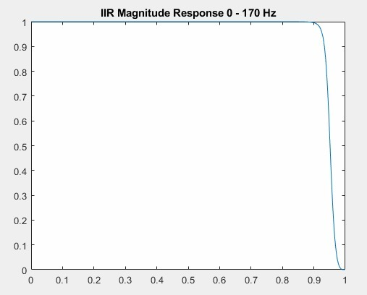

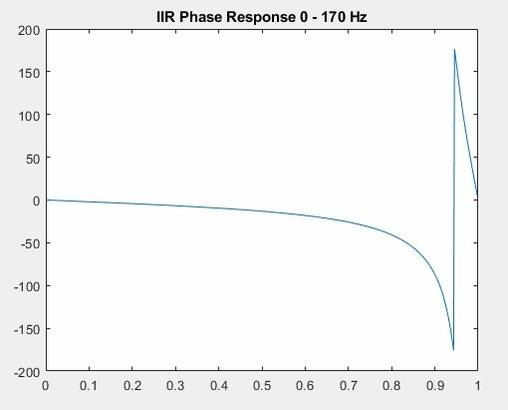

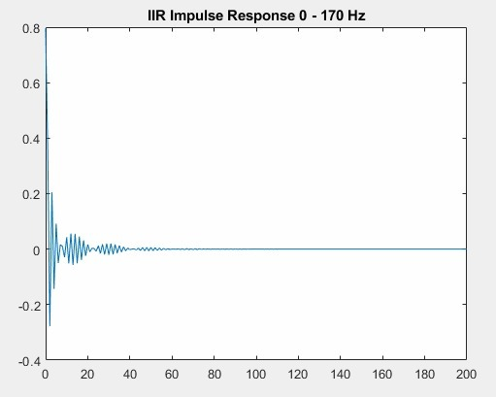

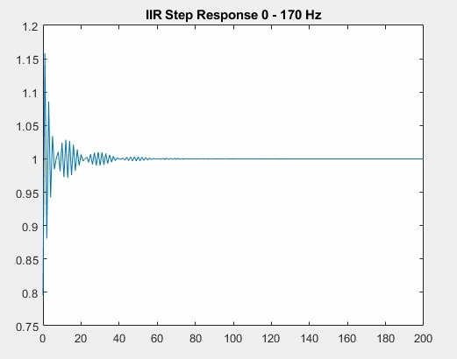

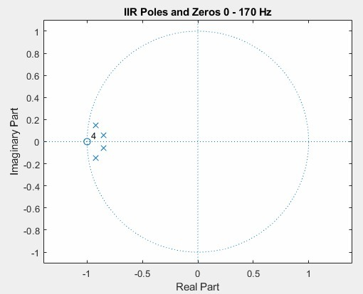

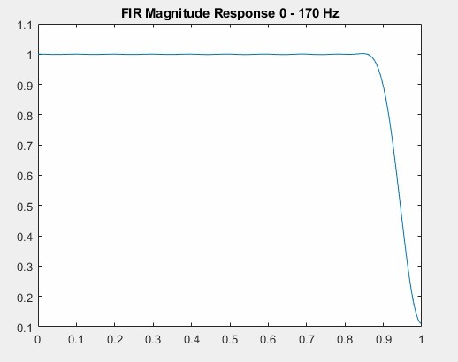

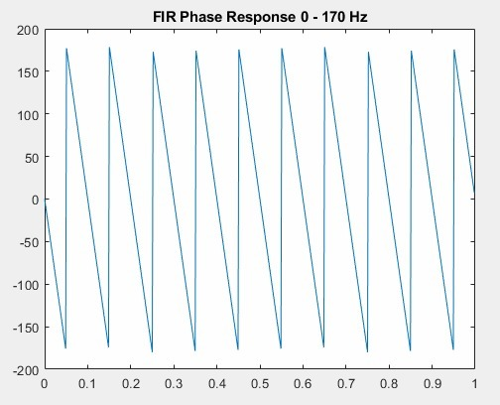

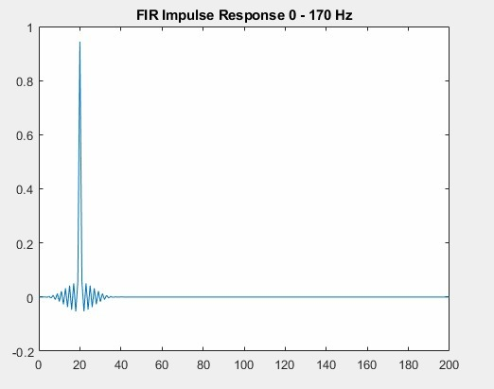

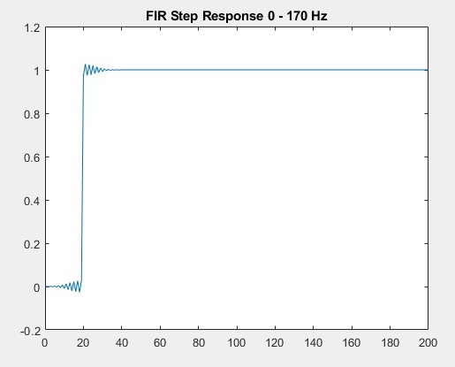

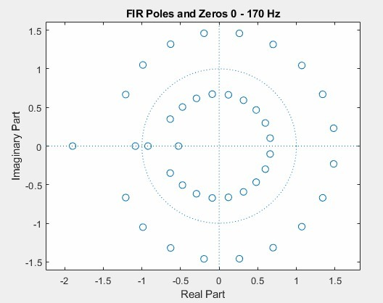

**Filter #2 (170 - 310 Hz)**

Sampling frequency used = 800 Hz

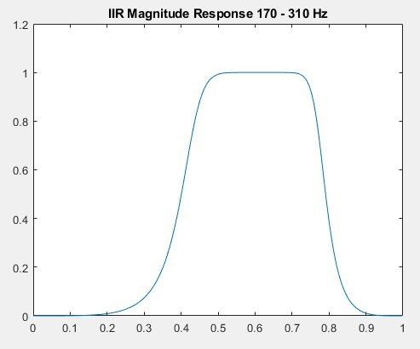

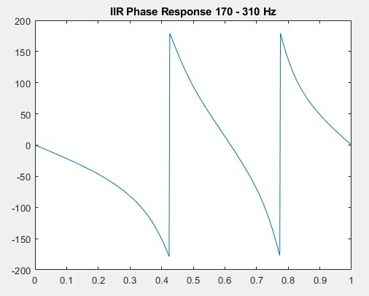

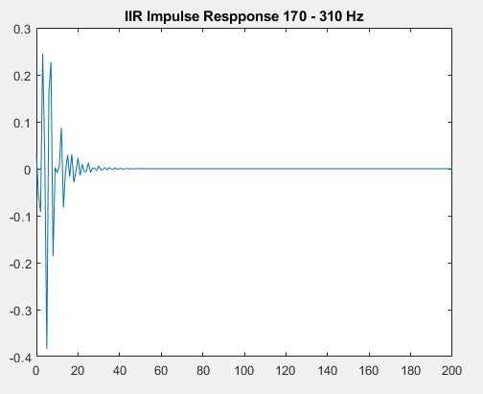

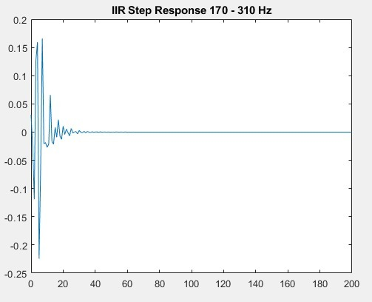

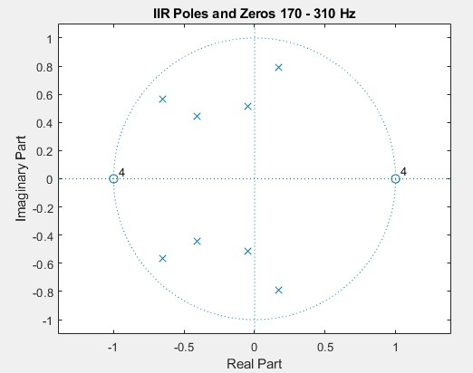

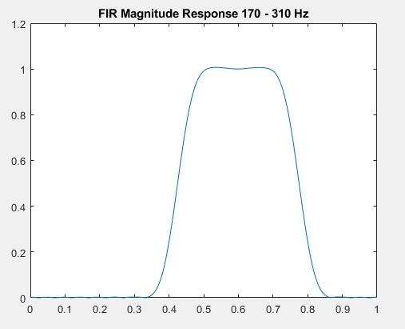

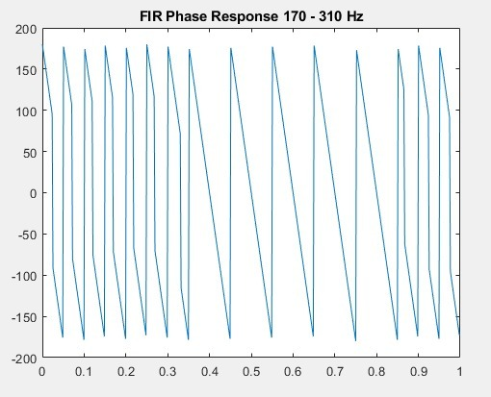

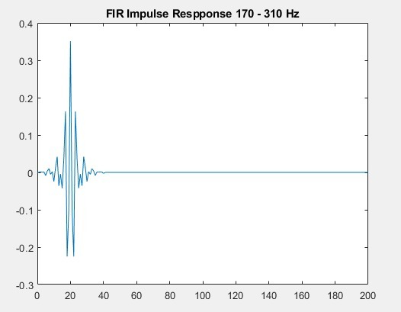

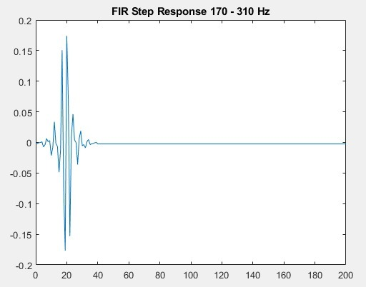

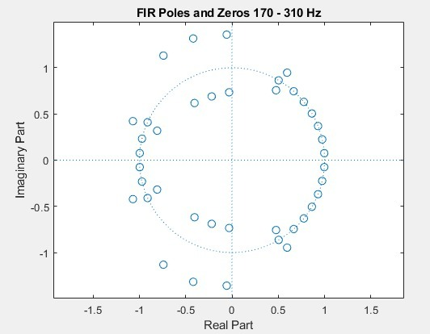

**Filter #3 (310 - 600 Hz)**

Sampling frequency used = 1500 Hz

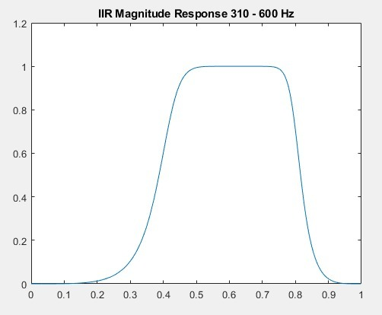

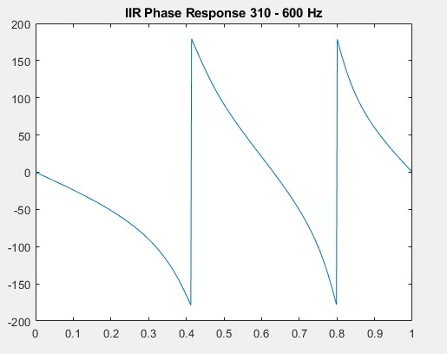

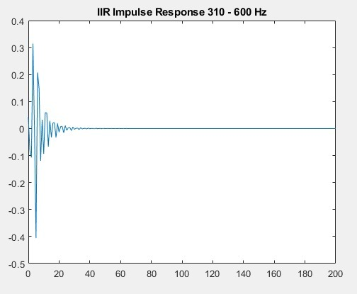

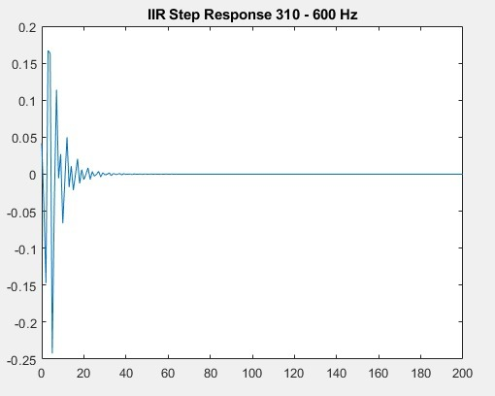

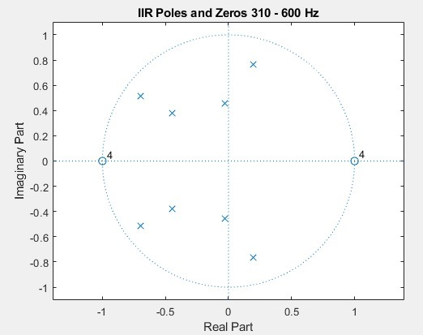

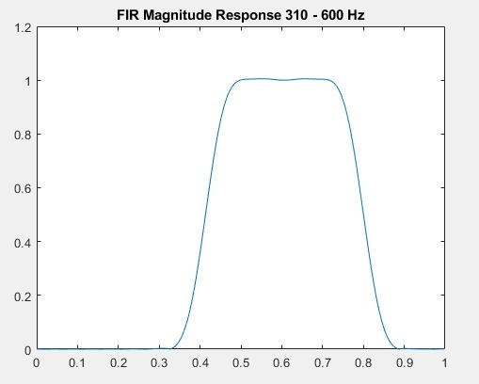

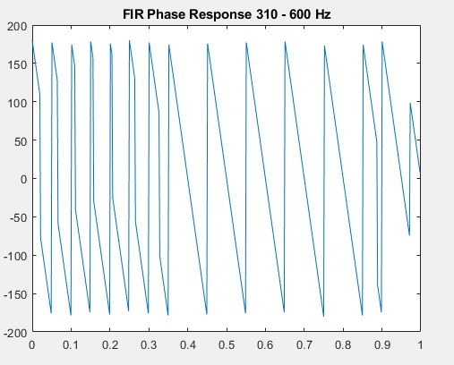

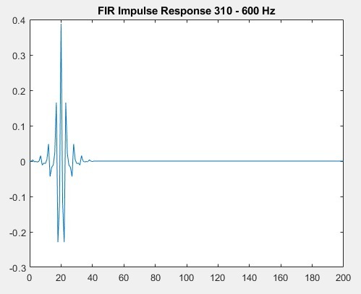

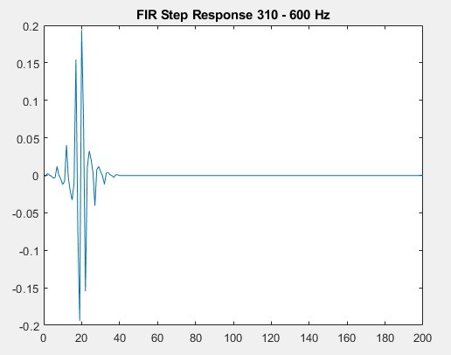

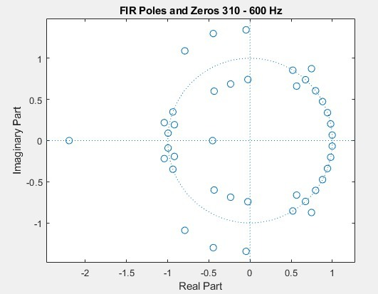

**Filter #4 (600 - 1000 Hz)**

Sampling frequency used = 2200 Hz

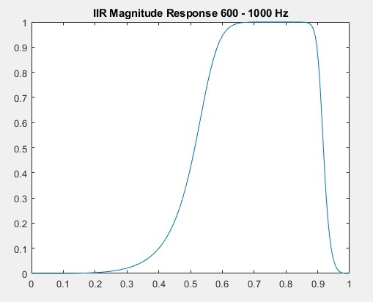

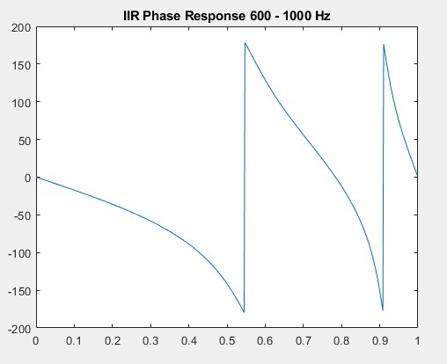

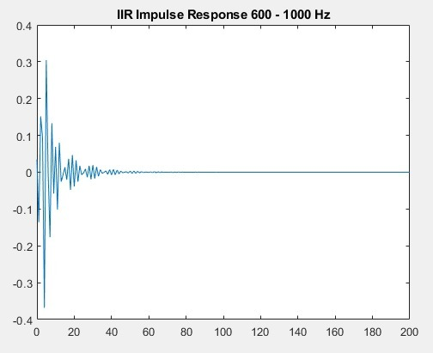

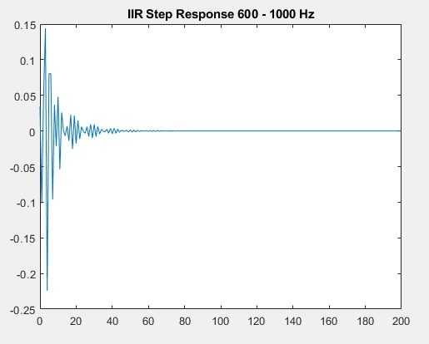

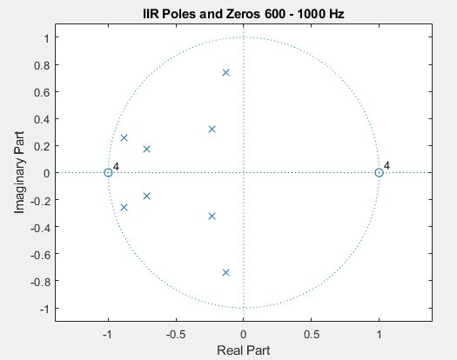

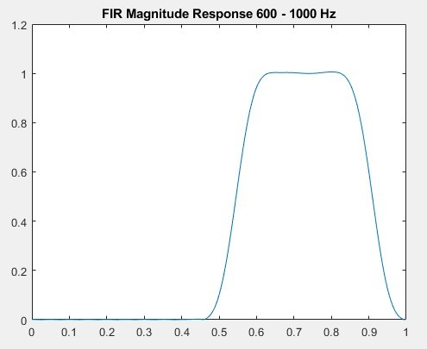

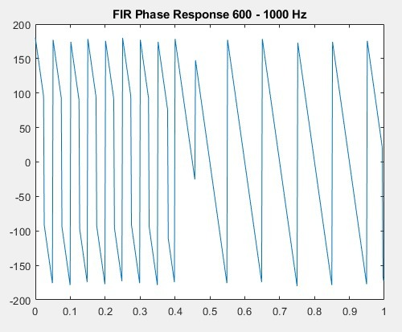

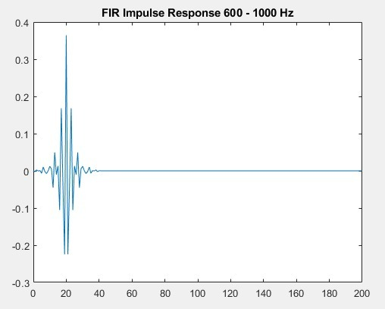

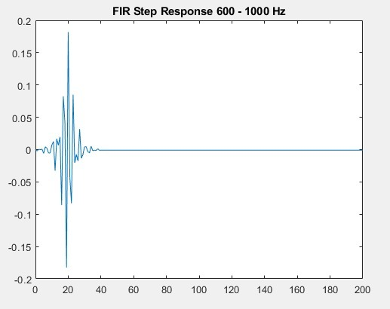

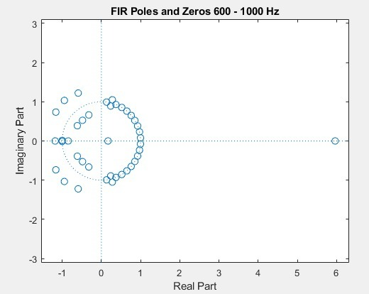

**Filter #5 (1 - 3 KHz)**

Sampling frequency used = 7 KHz

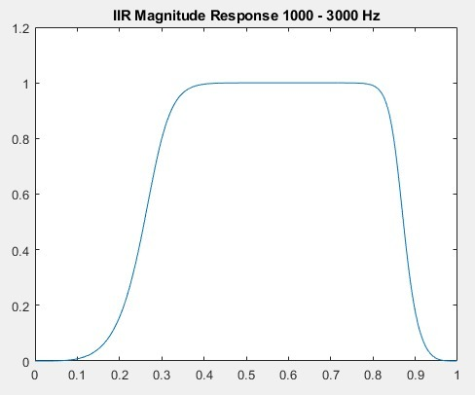

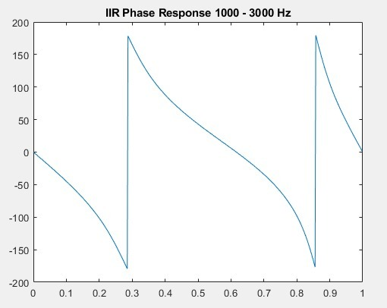

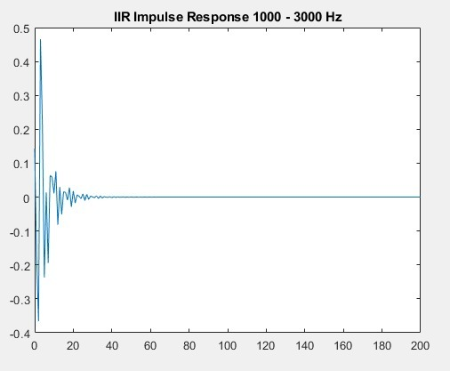

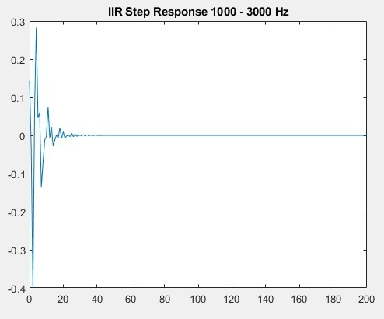

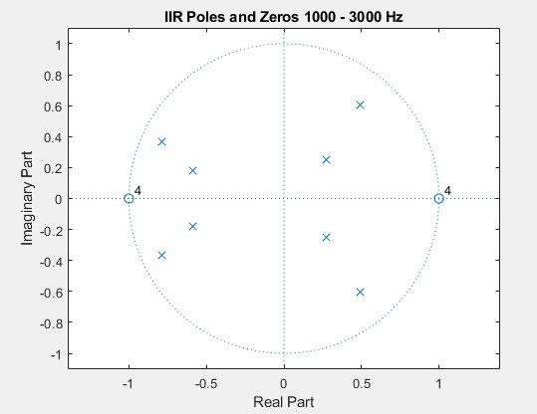

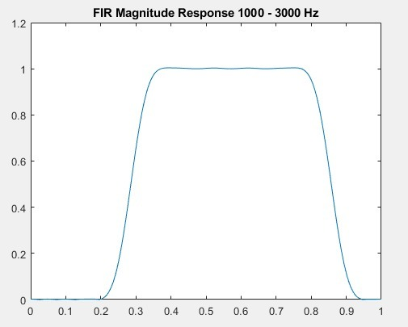

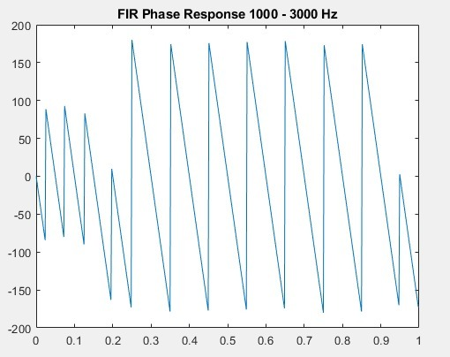

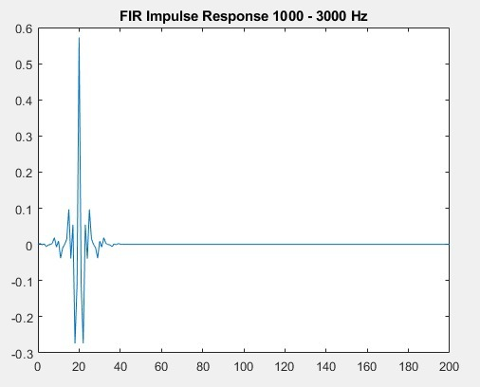

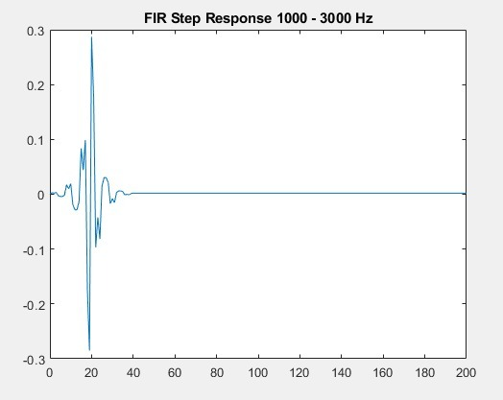

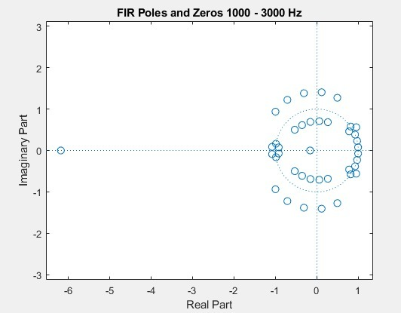

**Filter #6 (3 - 6 KHz)**

Sampling frequency used = 14 KHz

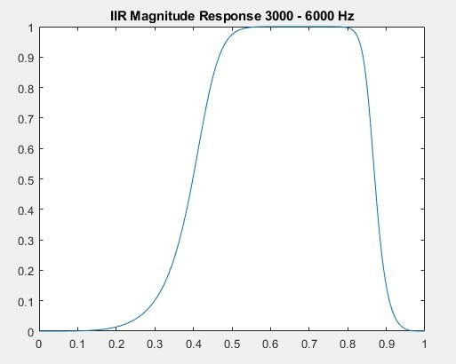

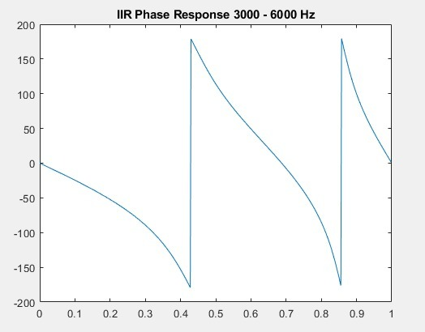

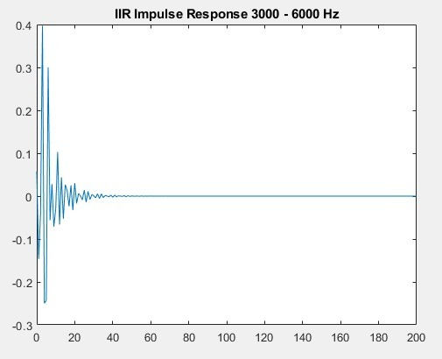

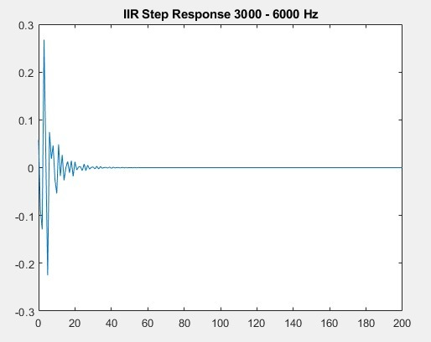

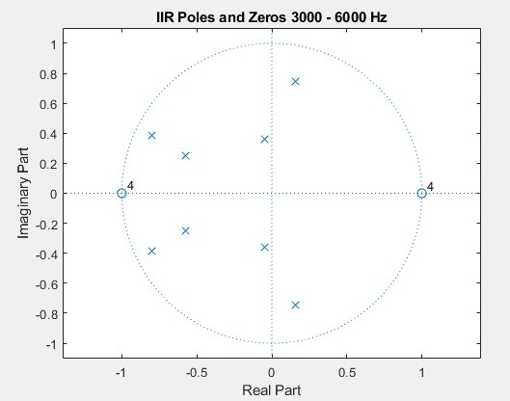

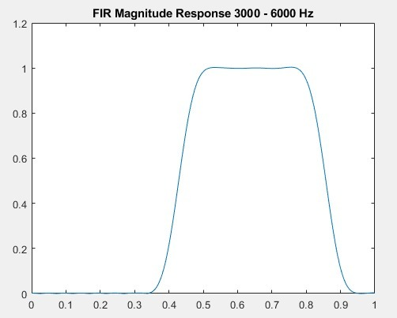

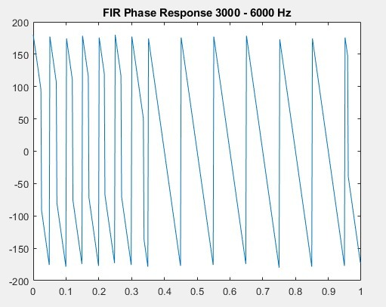

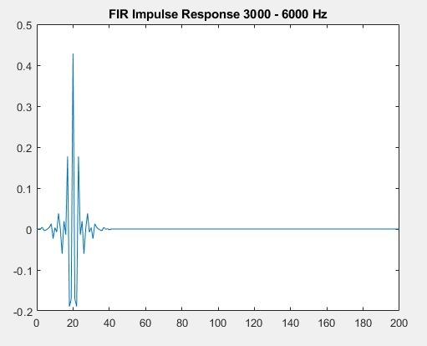

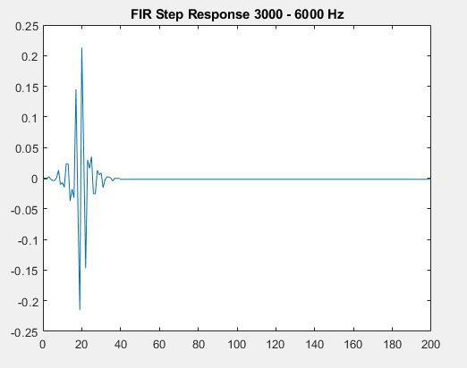

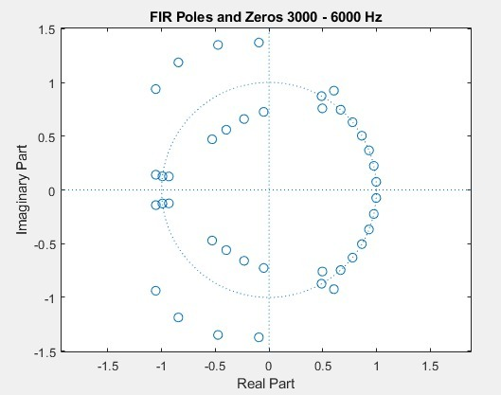

**Filter #7 (6 - 12 KHz)**

Sampling frequency used = 24500 Hz

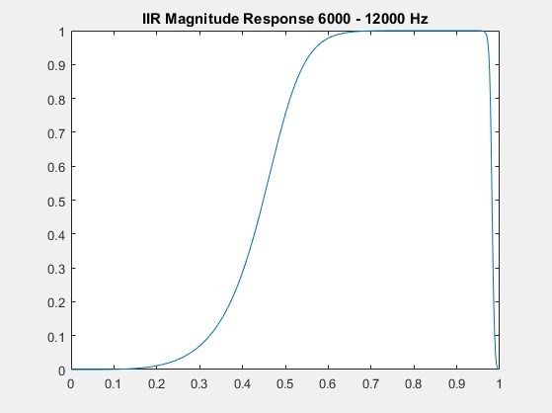

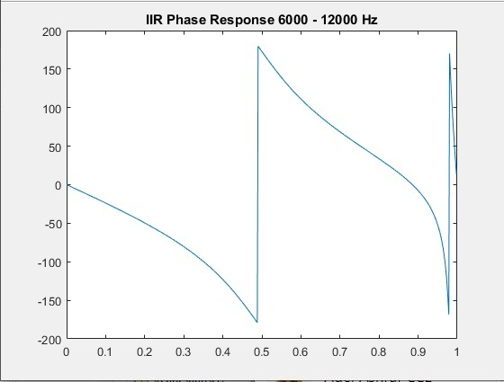

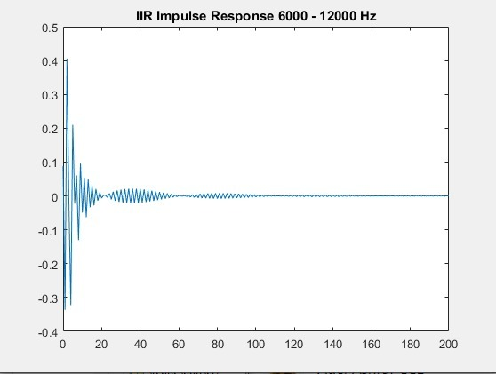

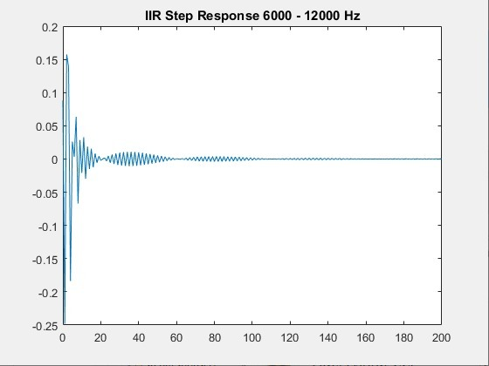

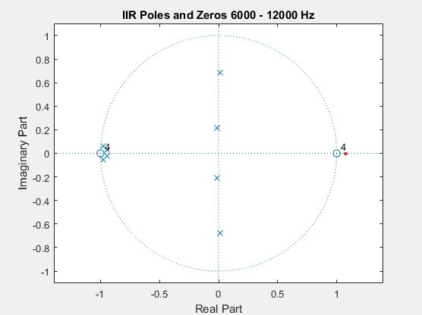

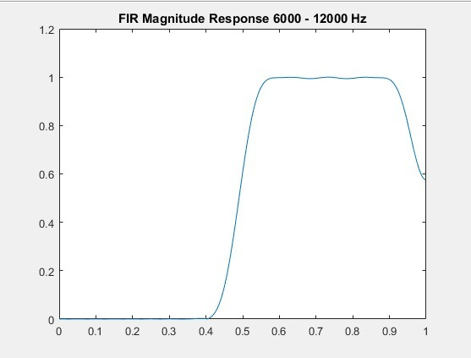

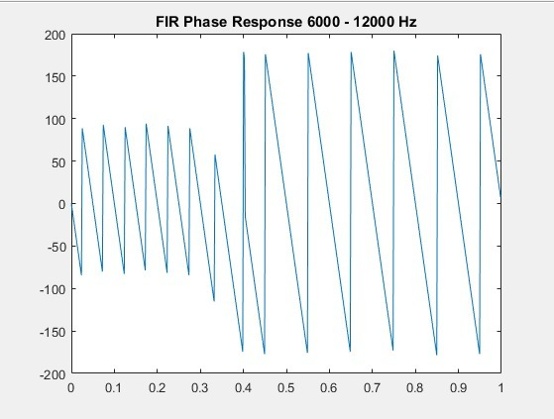

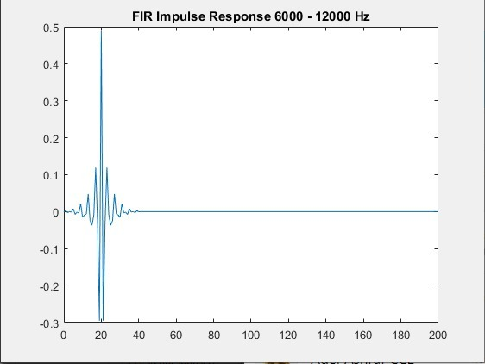

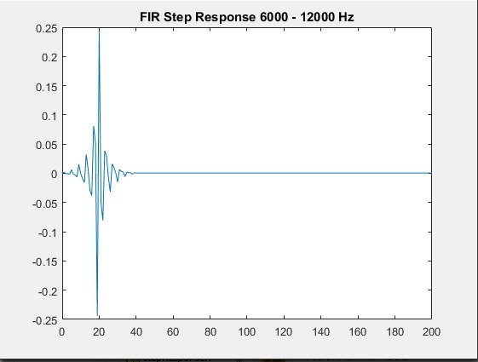

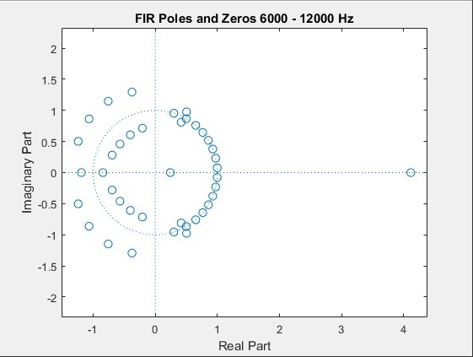

**Filter #8 (12 - 14 KHz)**

Sampling frequency used = 29 KHz

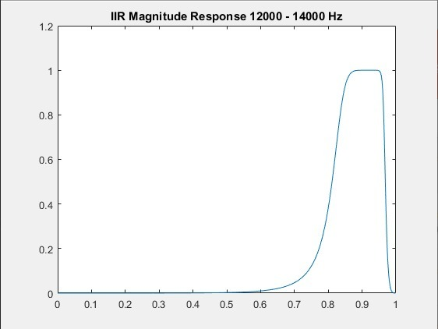

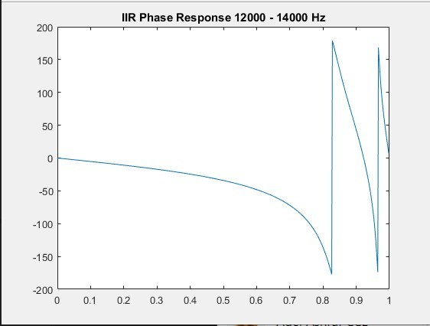

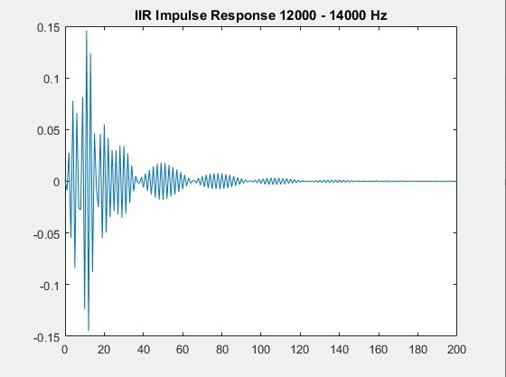

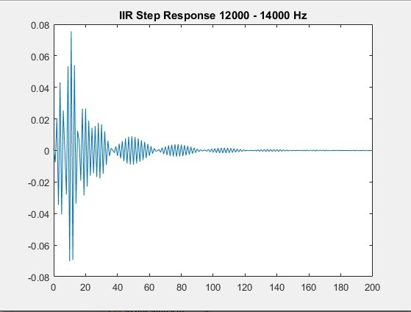

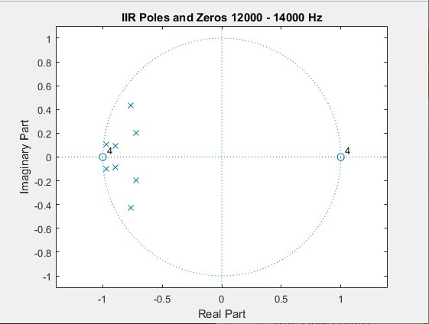

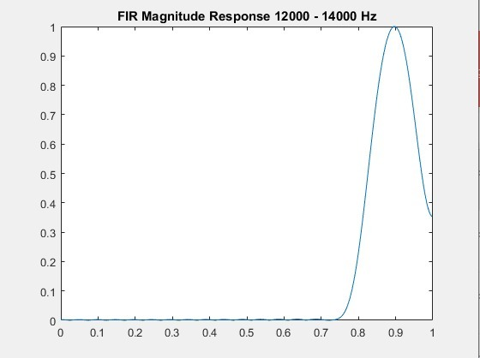

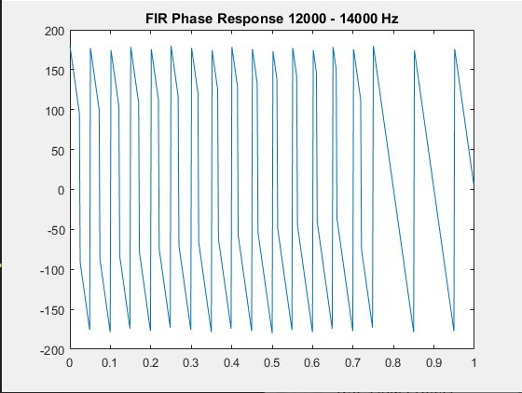

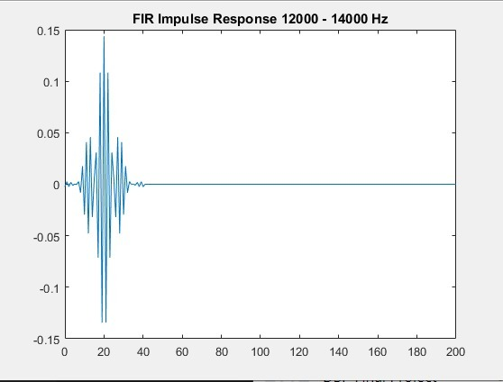

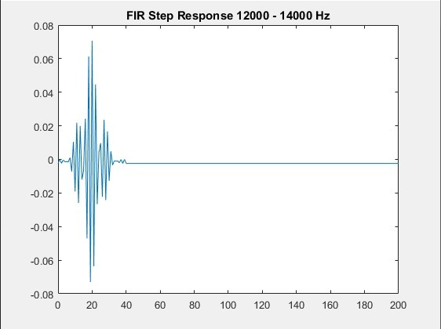

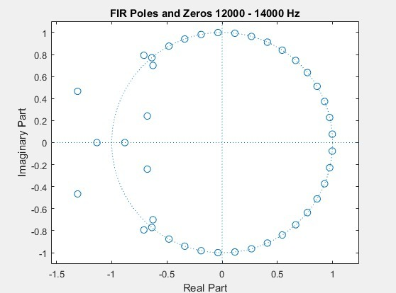

**Filter #9 (14 - 16 KHz)**

Sampling frequency used = 33 KHz

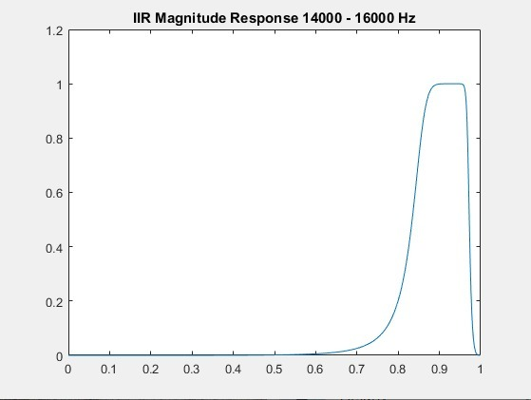

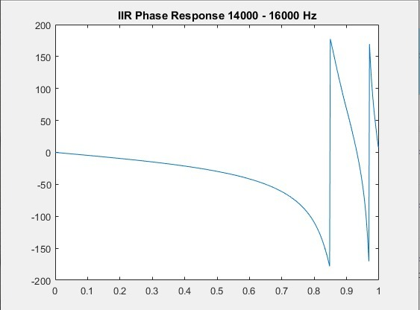

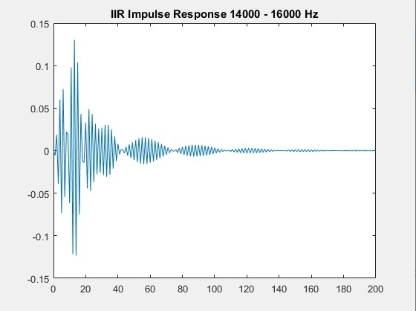

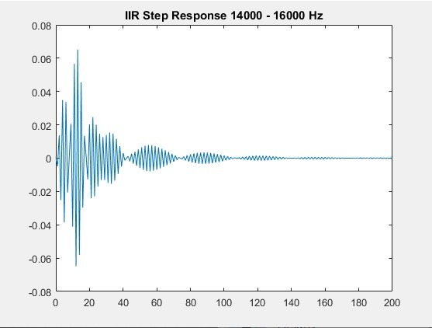

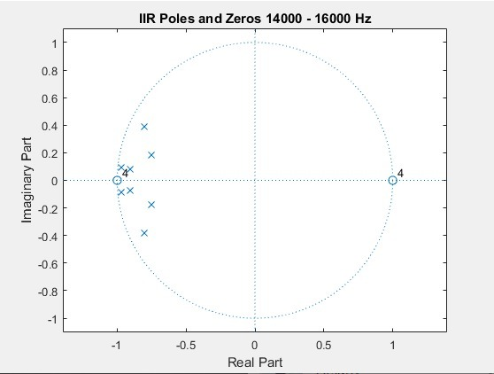

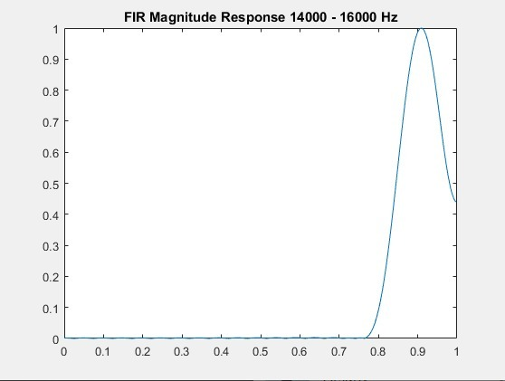

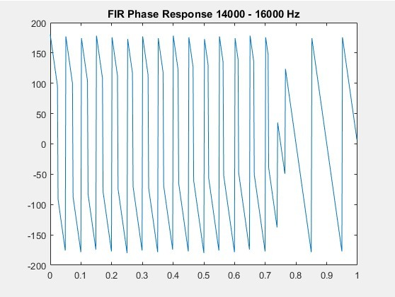

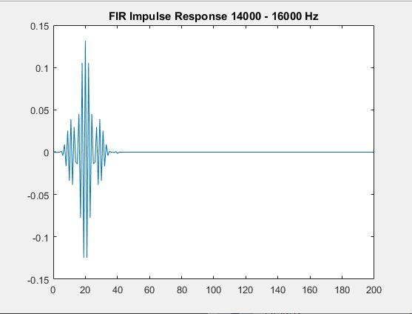

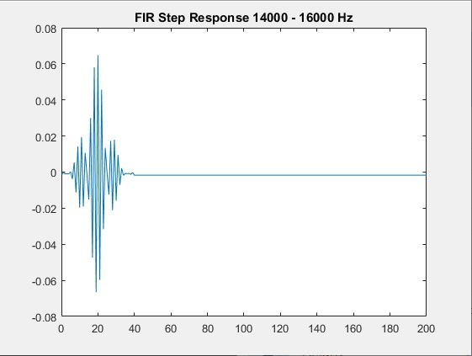

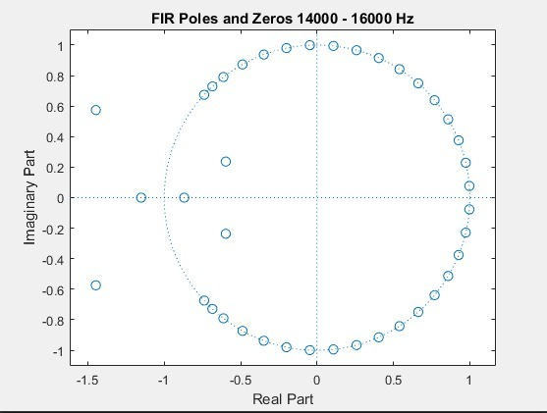

**Different Sample Runs**

**First Sample Run (FIR)**

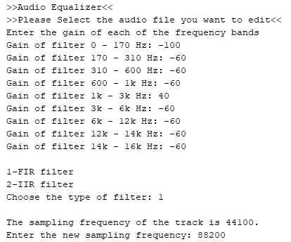

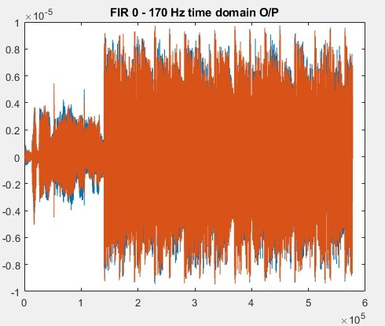

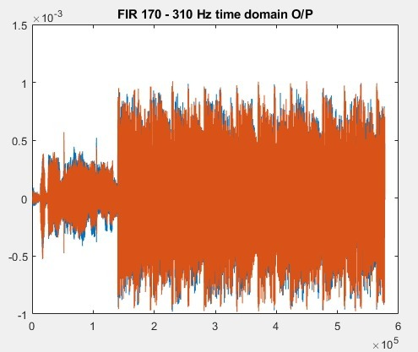

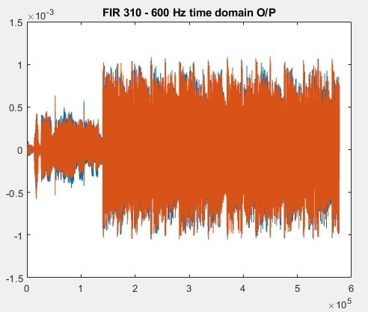

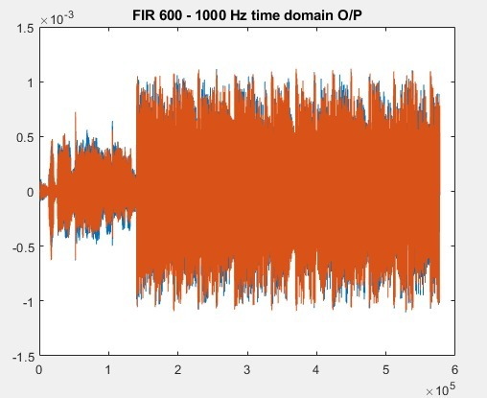

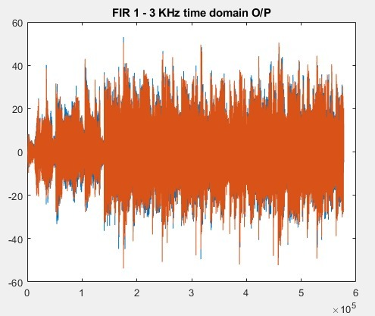

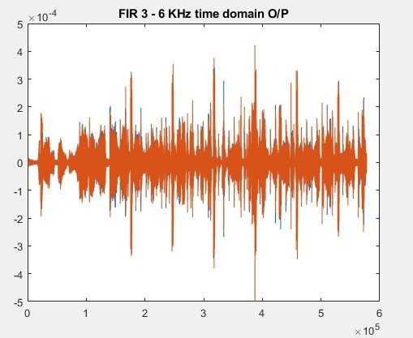

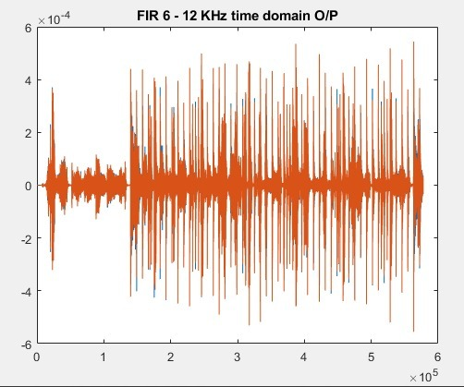

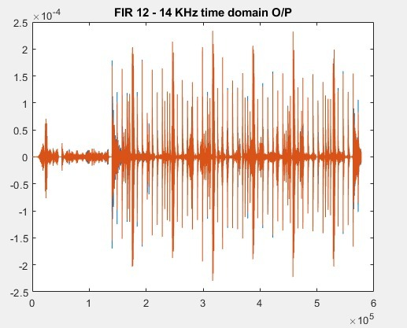

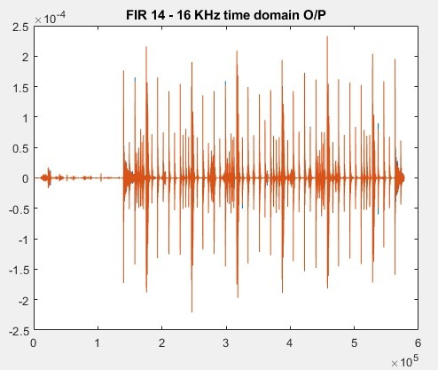

The Composite Signal in Time Domain

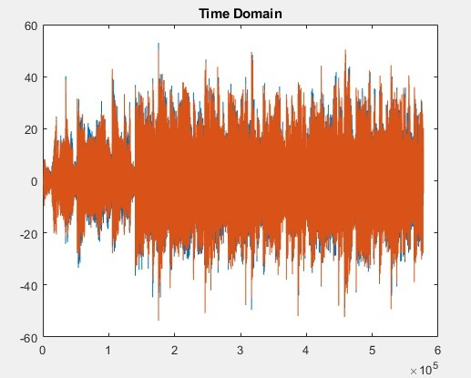

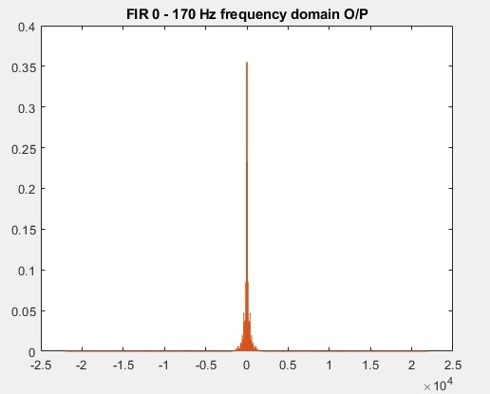

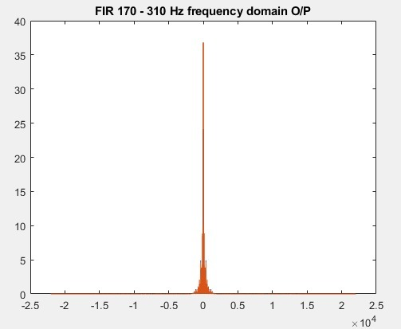

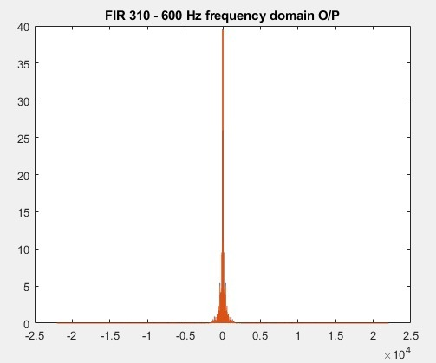

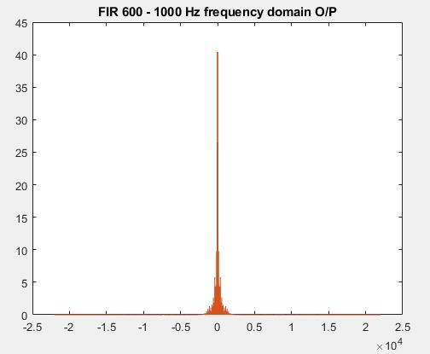

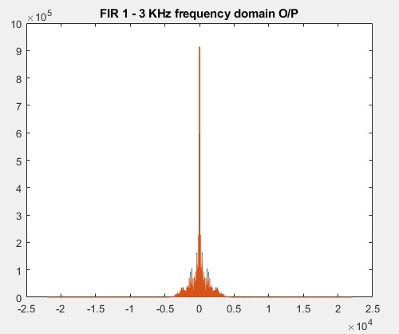

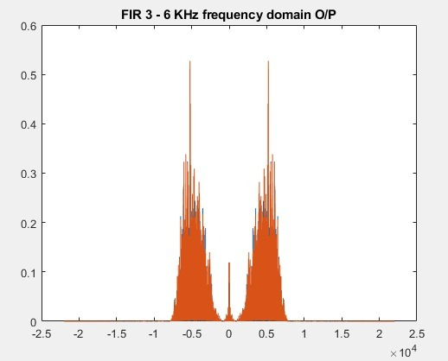

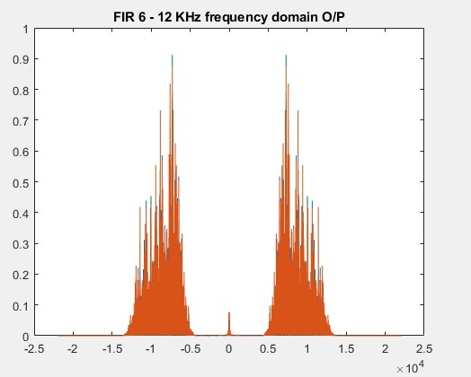

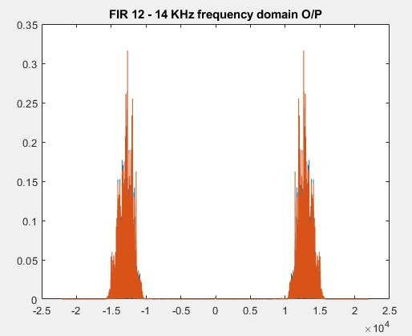

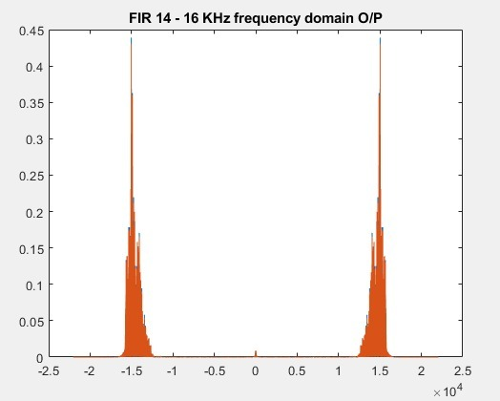

The Composite Signal in Frequency Domain

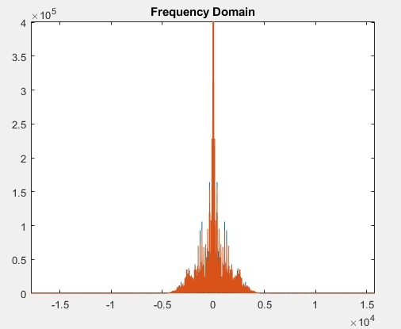

The modified composite signal with double sampling frequency

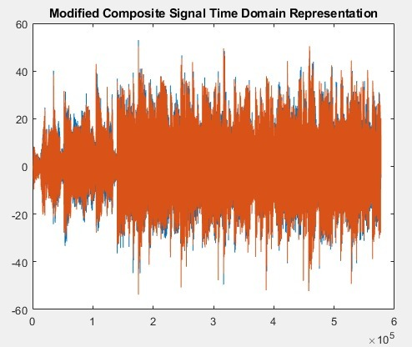

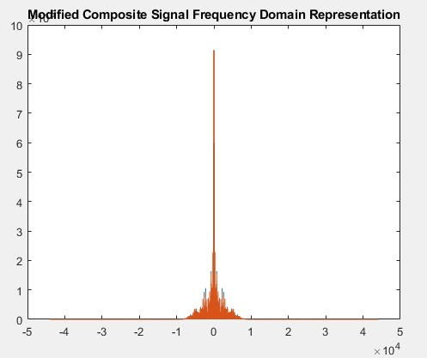

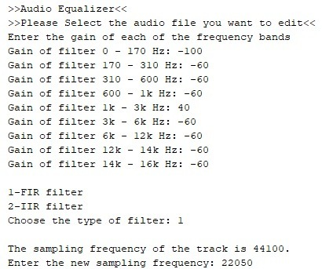



















The Composite Signal in Time Domain





















The Composite Signal in Frequency Domain



The modified composite signal with half the sampling frequency

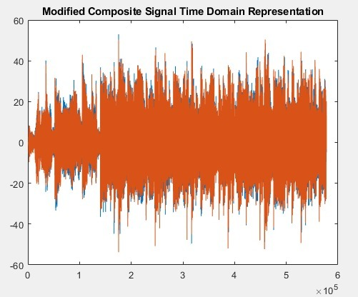

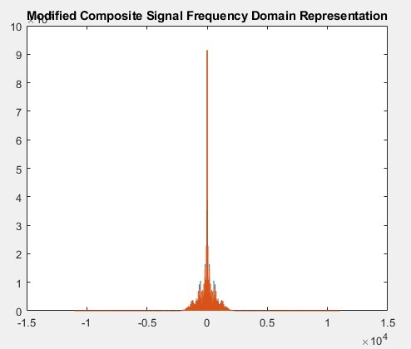

**First Sample Run (IIR)**

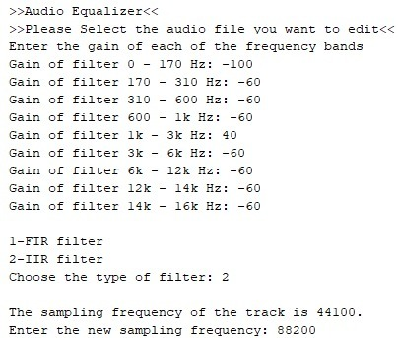

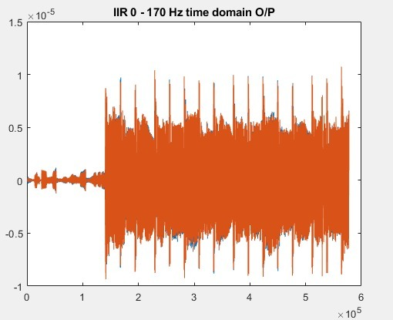

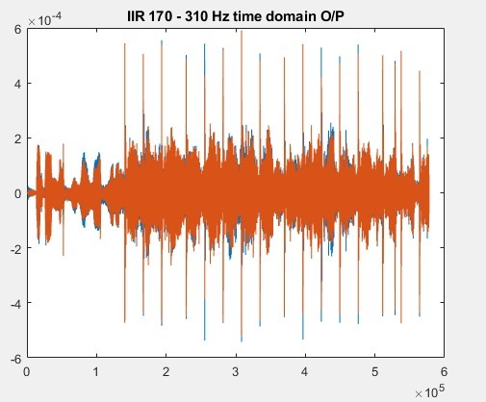

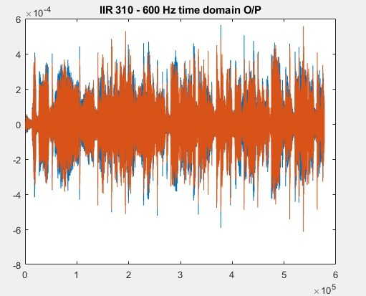

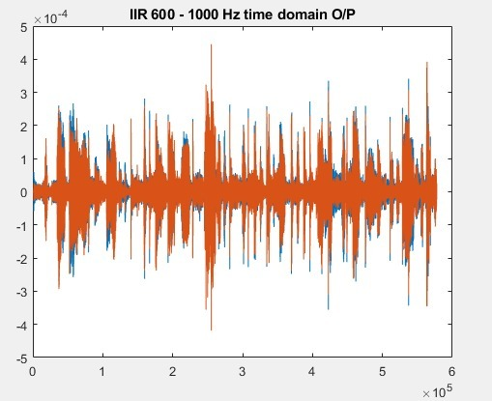

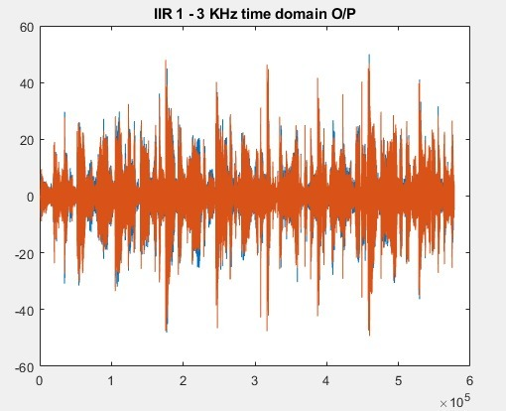

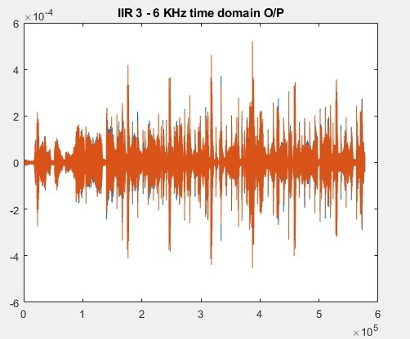

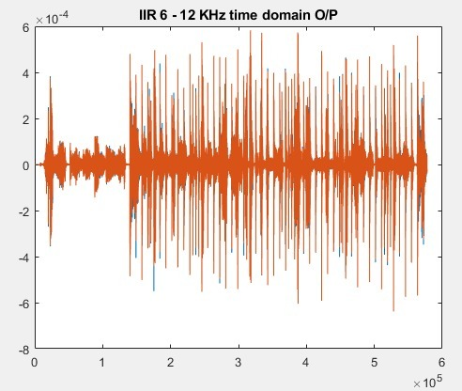

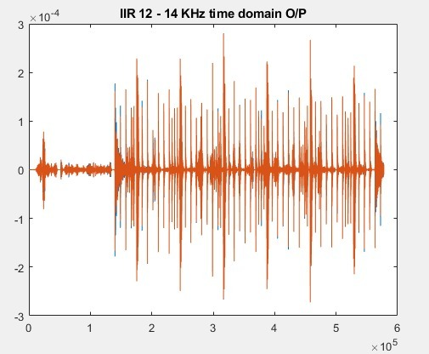

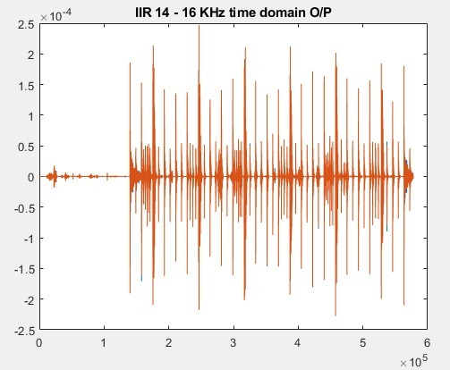

The Composite Signal in Time Domain

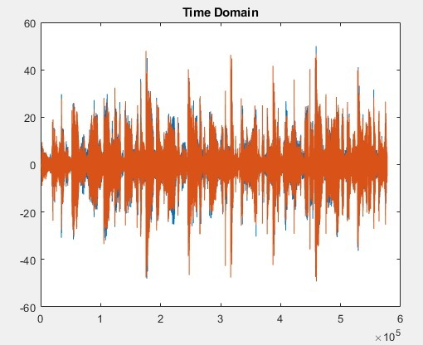

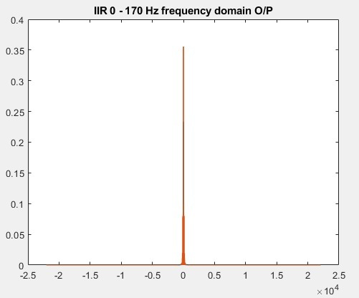

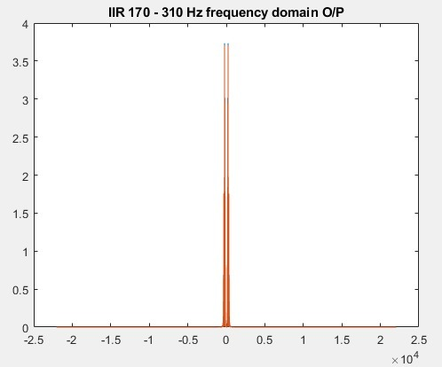

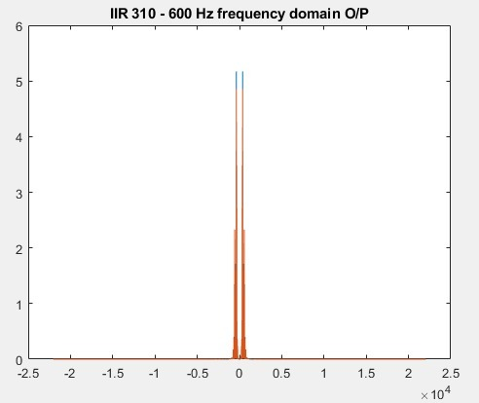

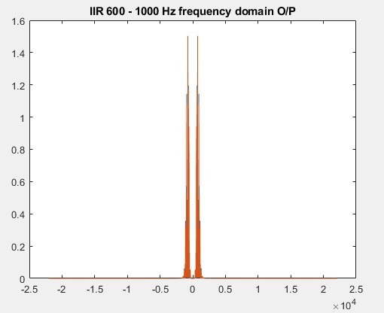

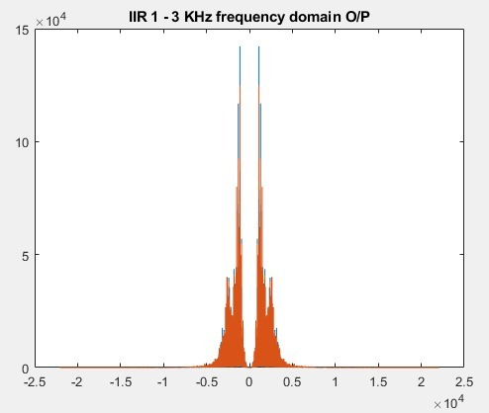

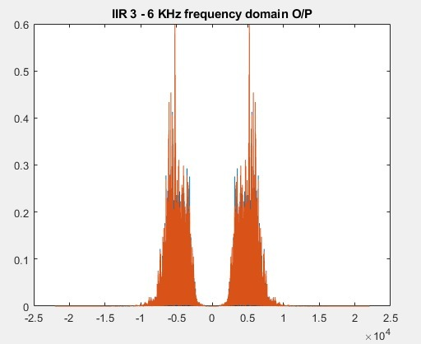

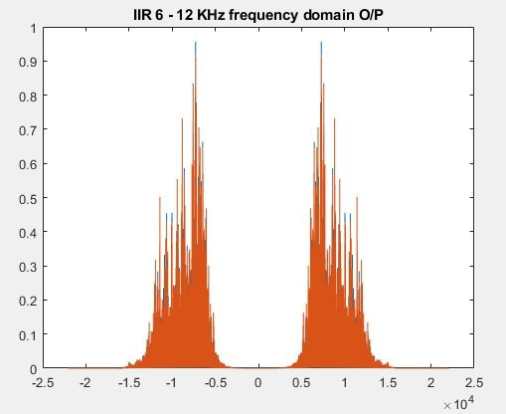

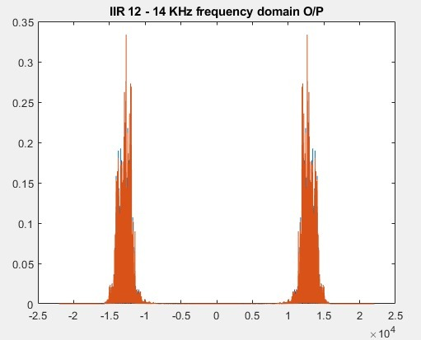

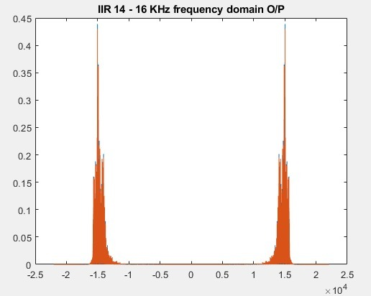

The Composite Signal in Frequency Domain

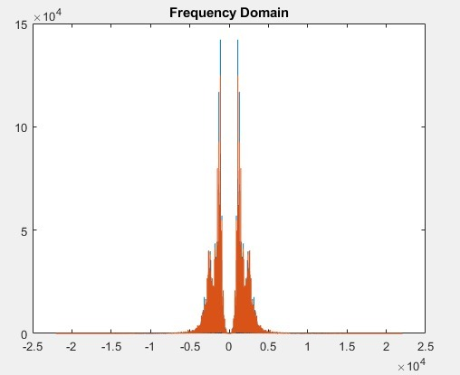

The modified composite signal with double the sampling frequency

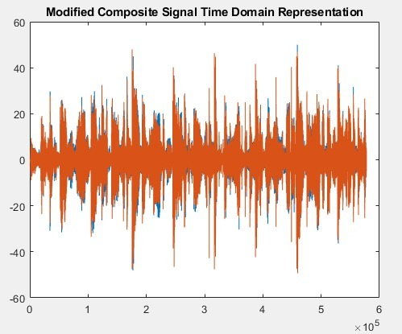

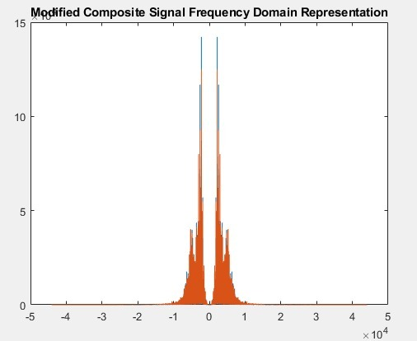

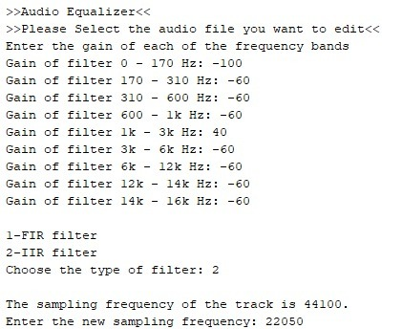



















The Composite Signal in Time Domain





















The Composite Signal in Frequency Domain



The modified composite signal with half the sampling frequency

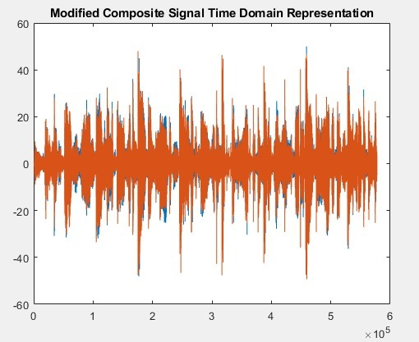

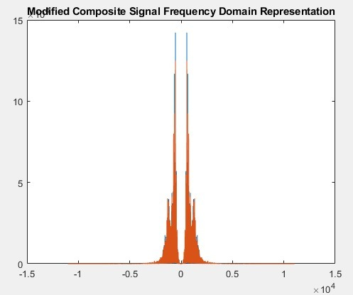

**Second Sample Run (FIR)**

**Note:** Low frequency sound track

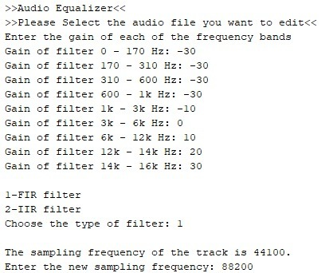

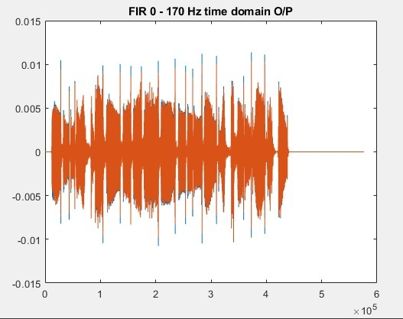

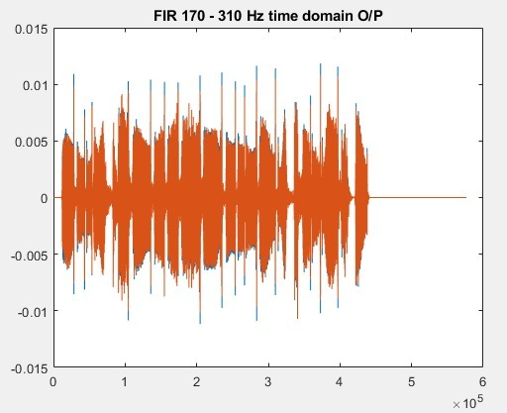

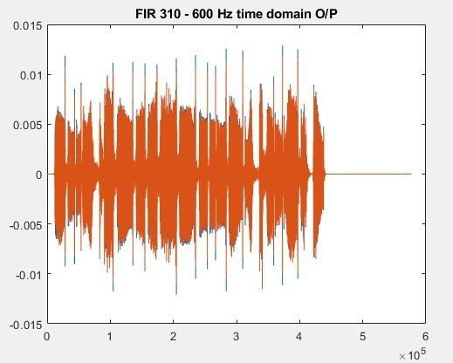

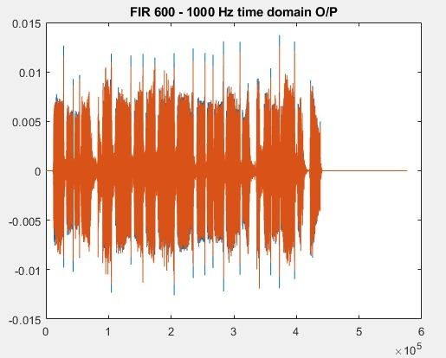

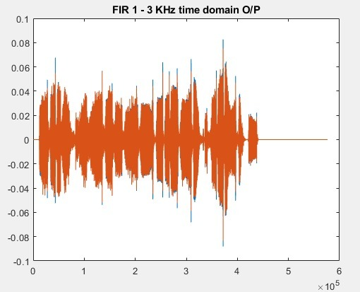

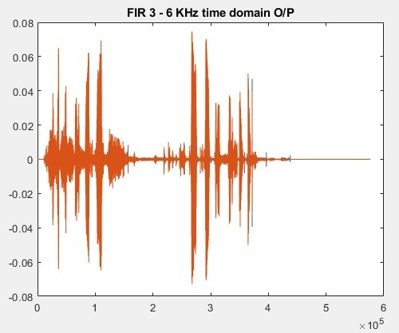

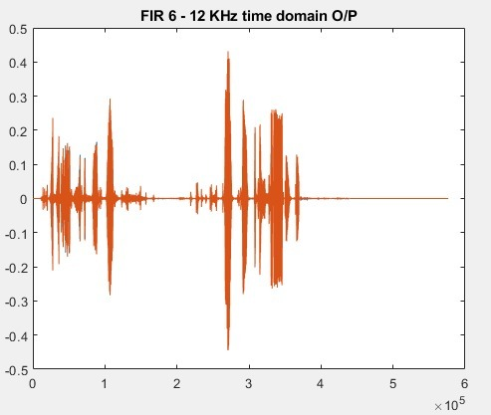

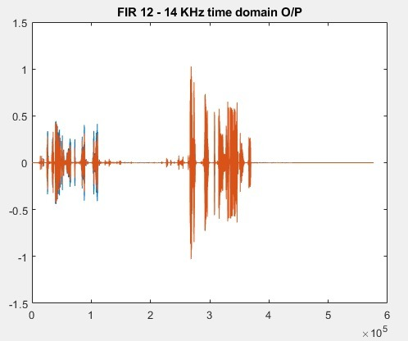

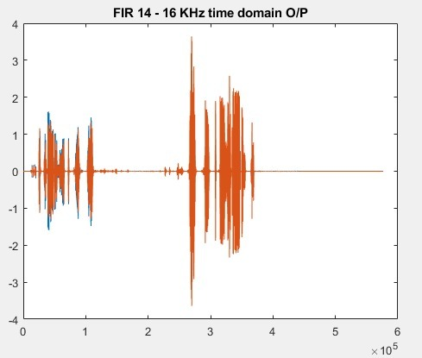

The Composite Signal in Time Domain

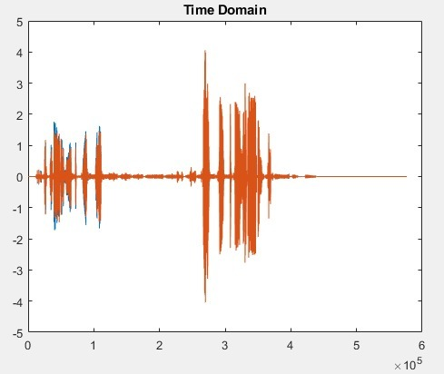

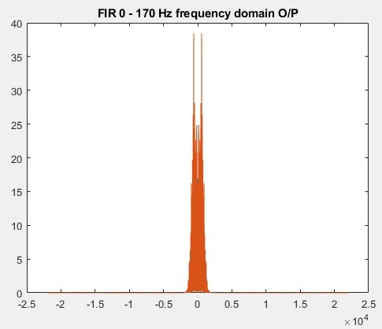

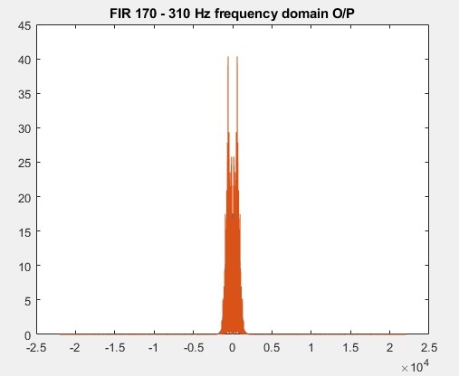

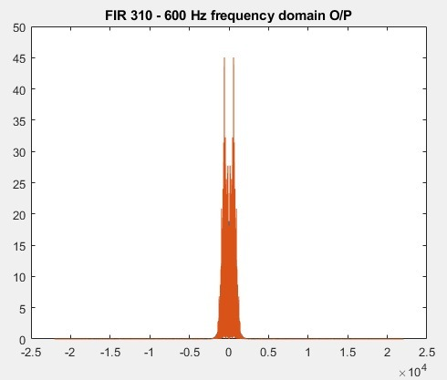

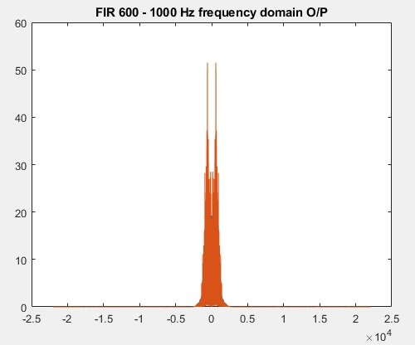

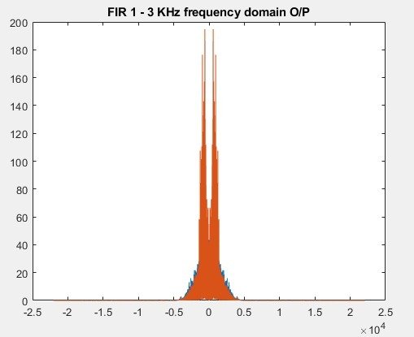

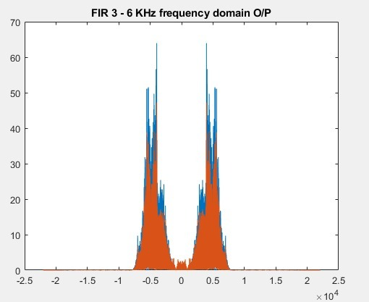

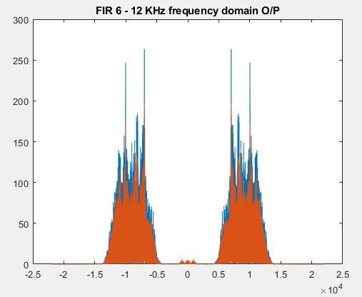

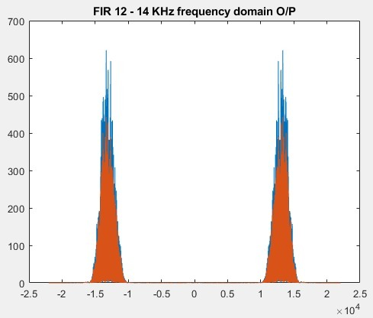

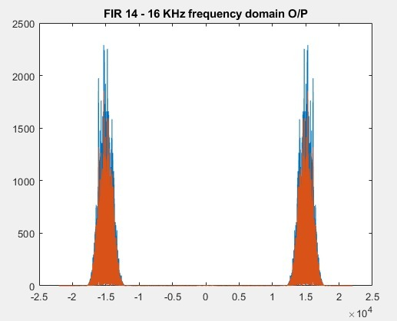

The Composite Signal in Frequency Domain

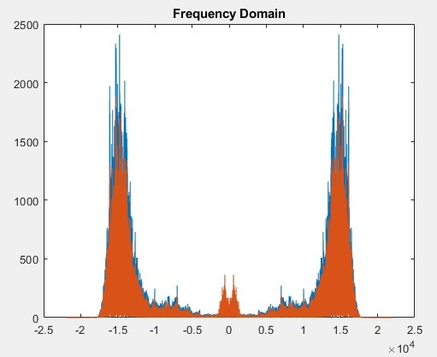

The modified composite signal with double the sampling frequency

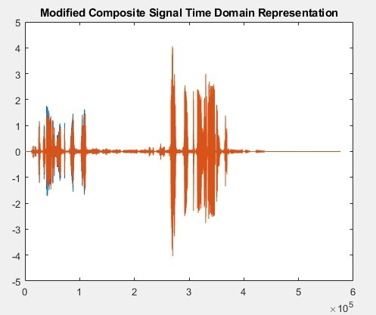

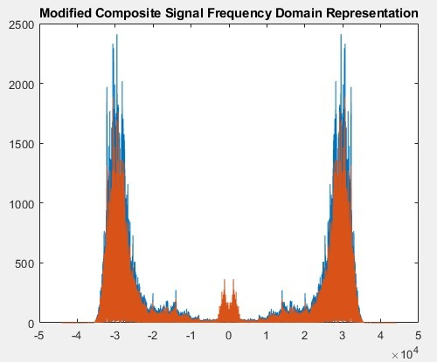

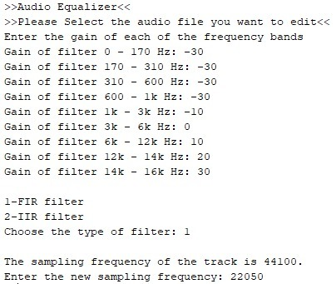



















The Composite Signal in Time Domain





















The Composite Signal in Frequency Domain



The modified composite signal with half the sampling frequency

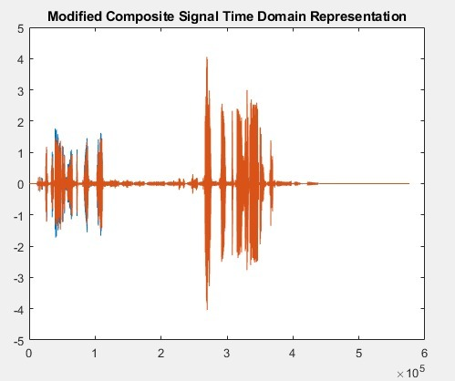

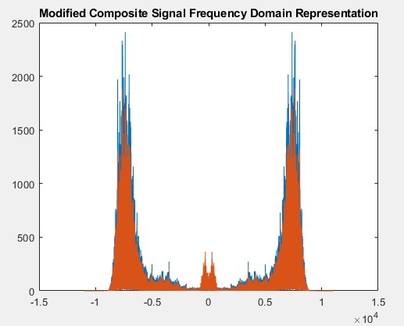

**Second Sample Run (IIR)**

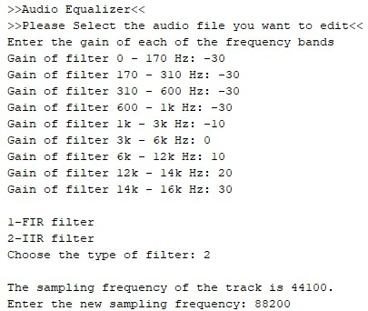

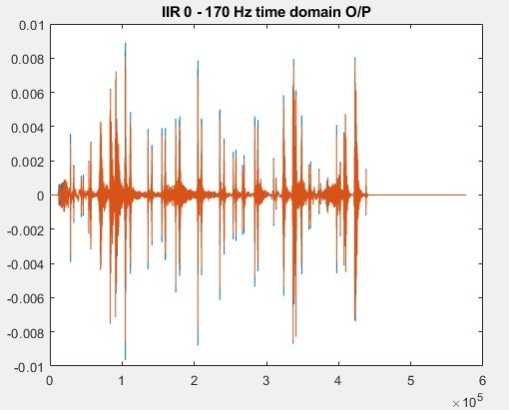

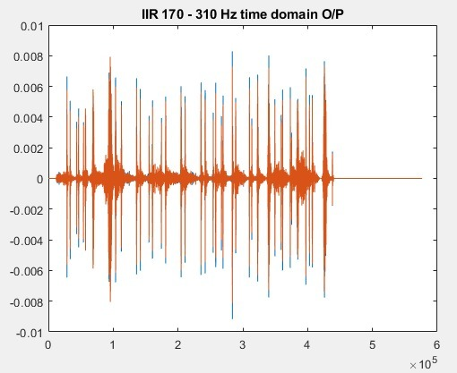

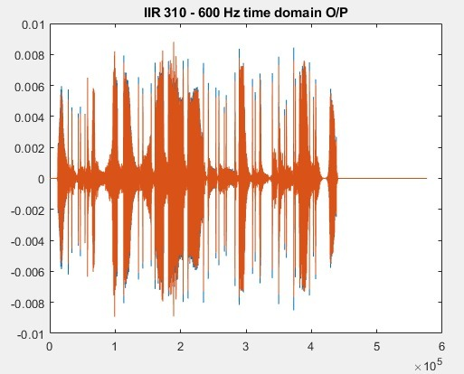

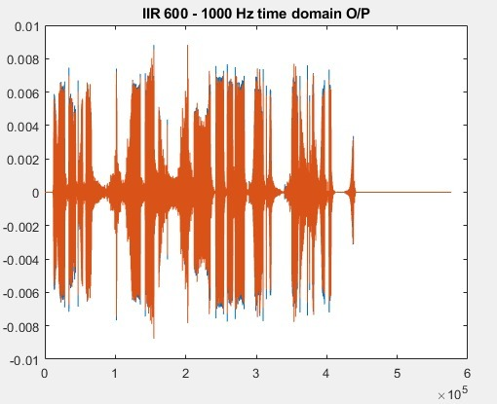

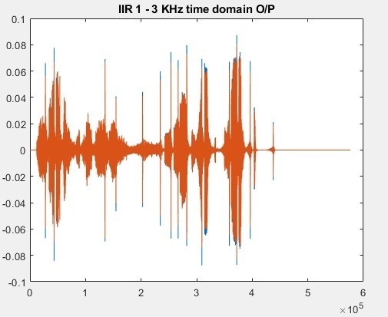

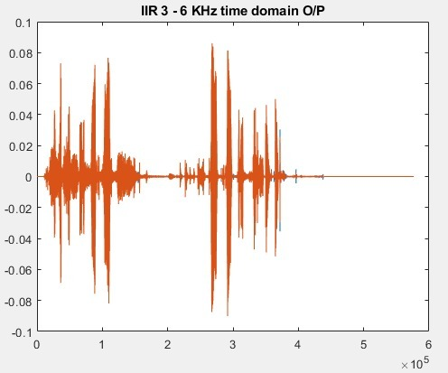

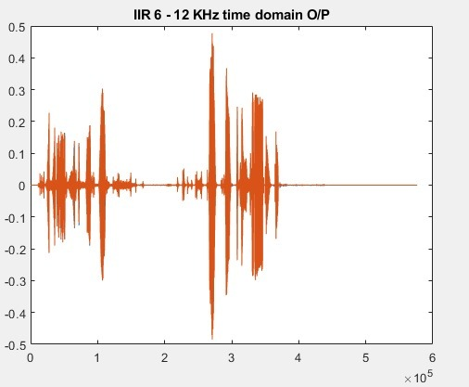

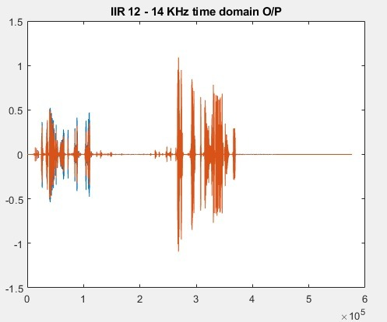

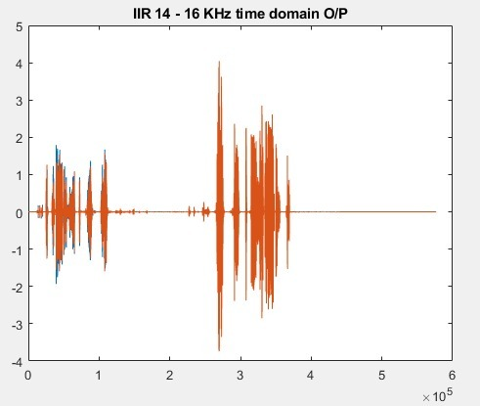

The Composite Signal in Time Domain

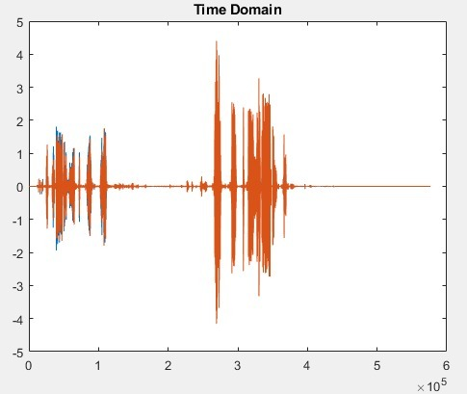

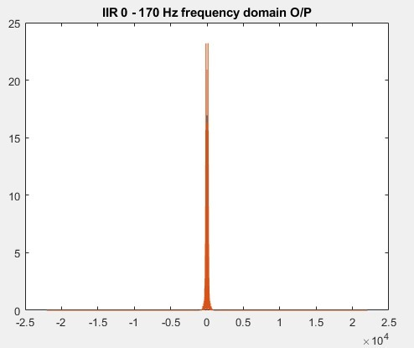

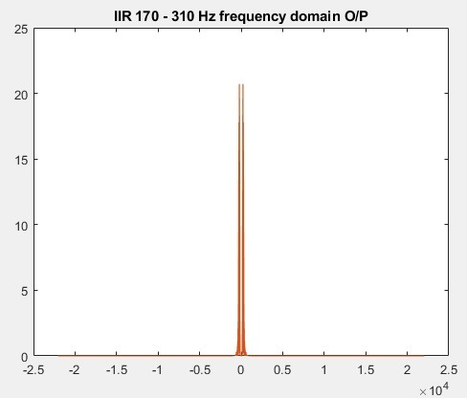

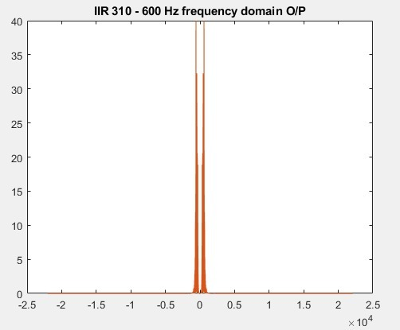

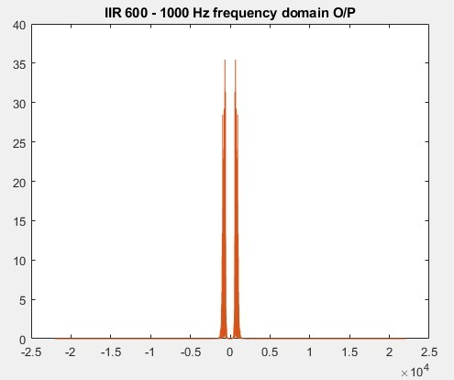

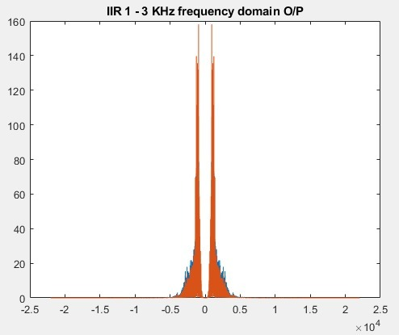

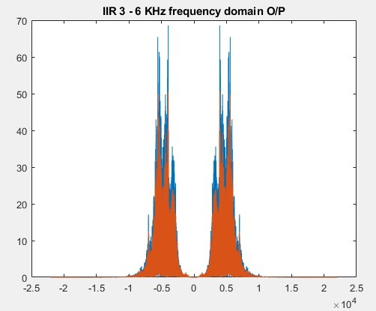

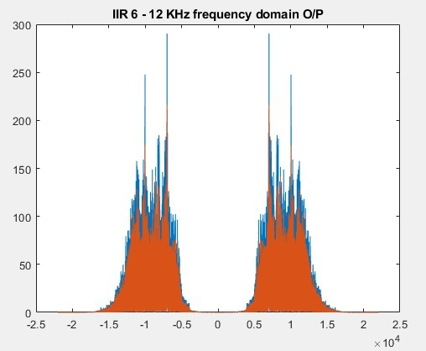

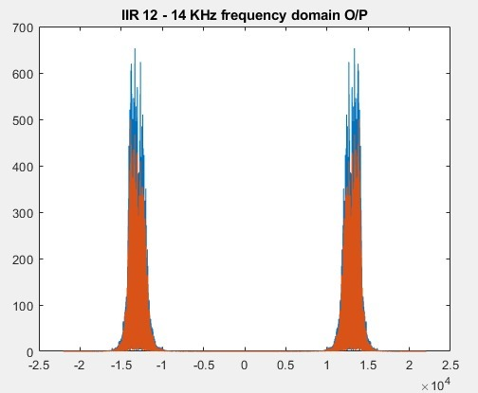

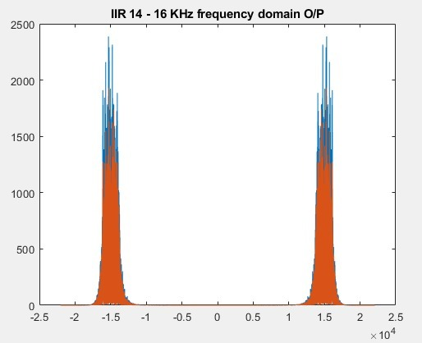

The Composite Signal in Frequency Domain

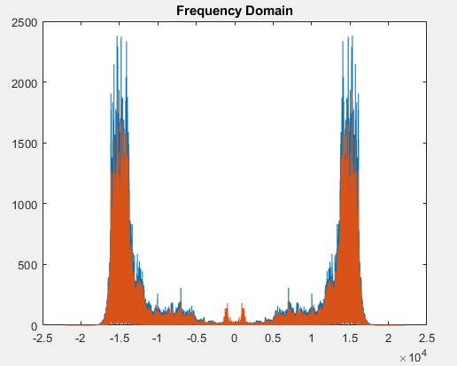

The modified composite signal with double the sampling frequency

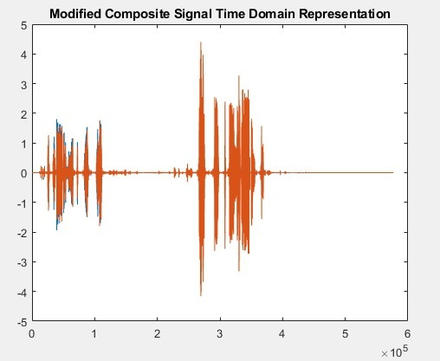

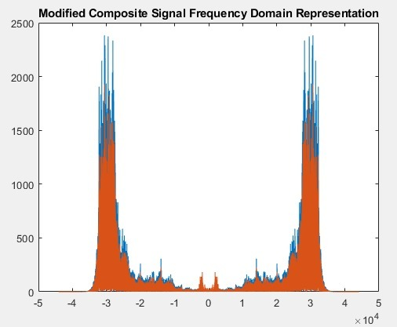

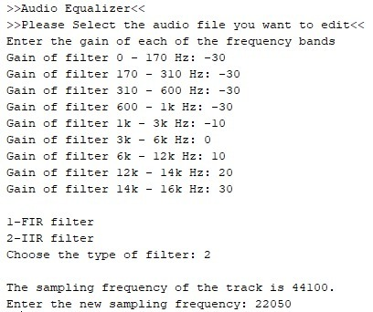



















The Composite Signal in Time Domain





















The Composite Signal in Frequency Domain



The modified composite signal with half the sampling frequency

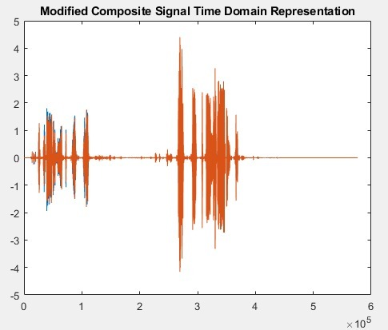

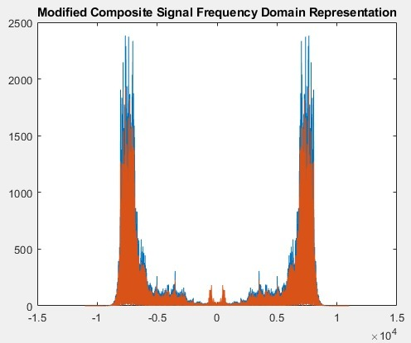

**Third Sample Run (FIR)**

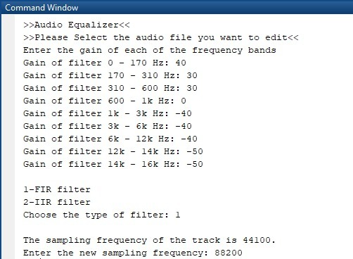

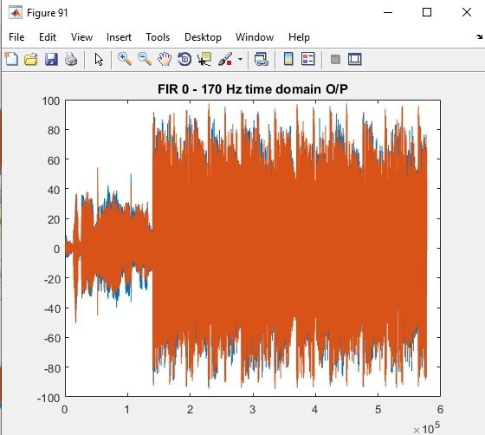

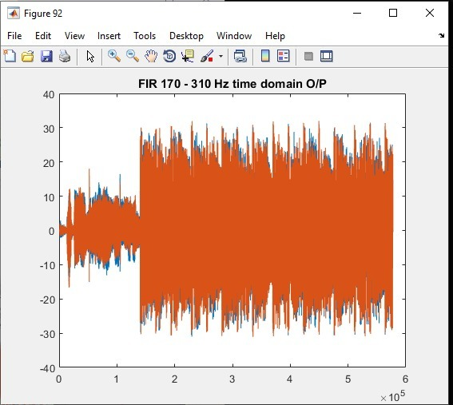

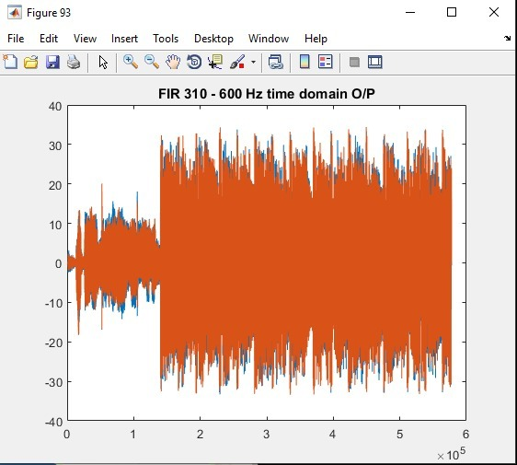

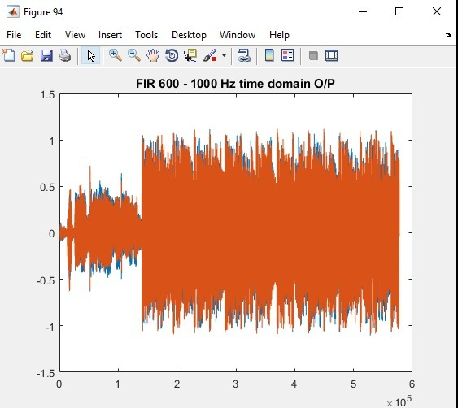

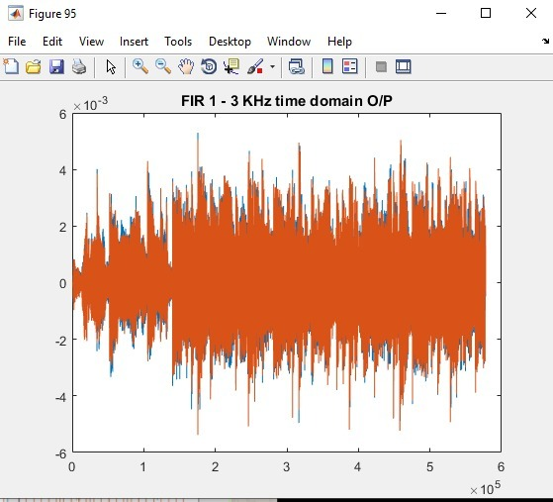

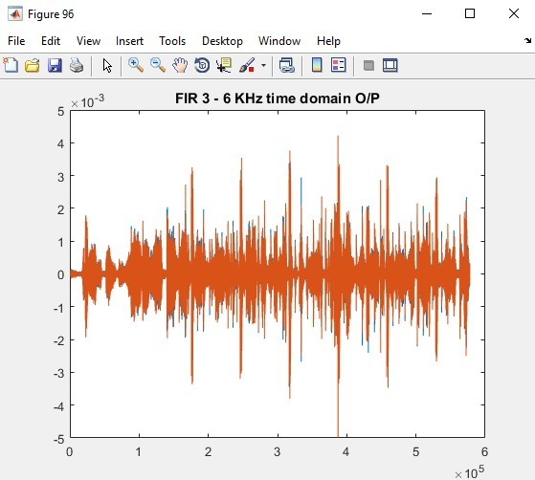

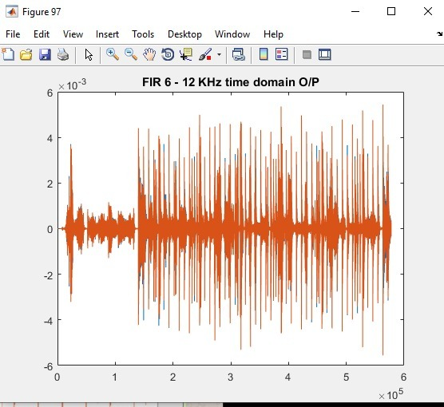

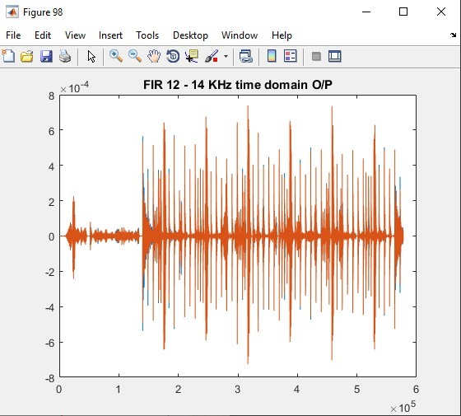

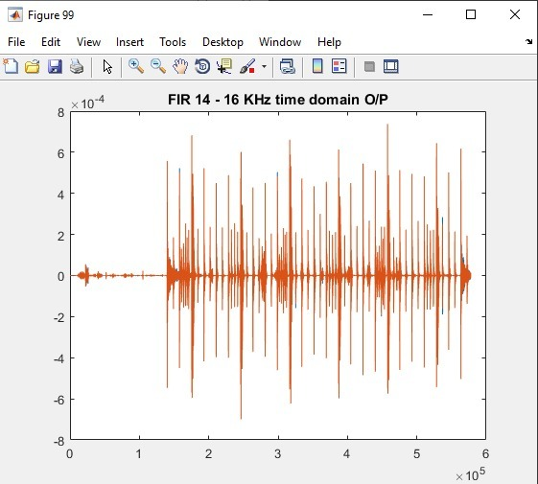

The Composite Signal in Time Domain

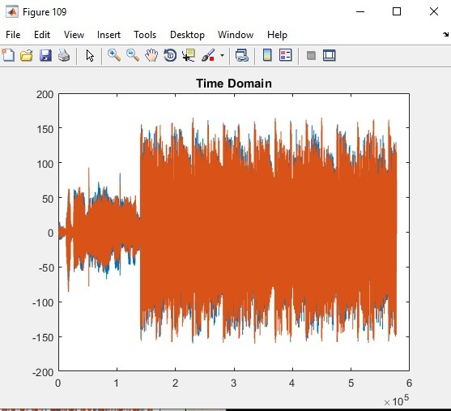

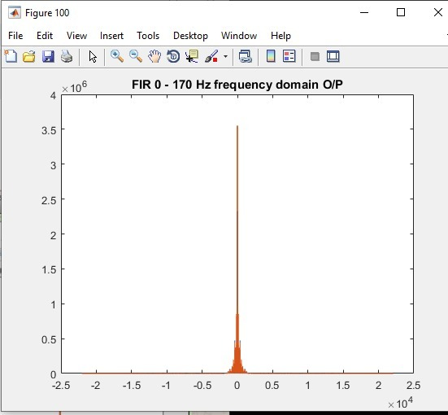

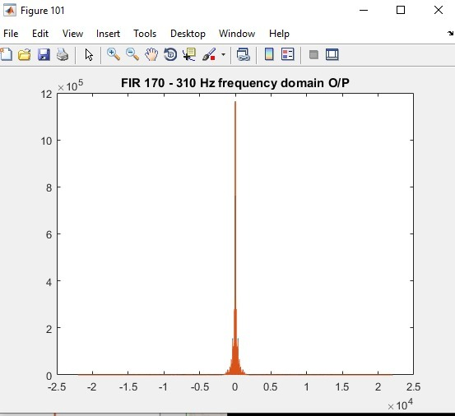

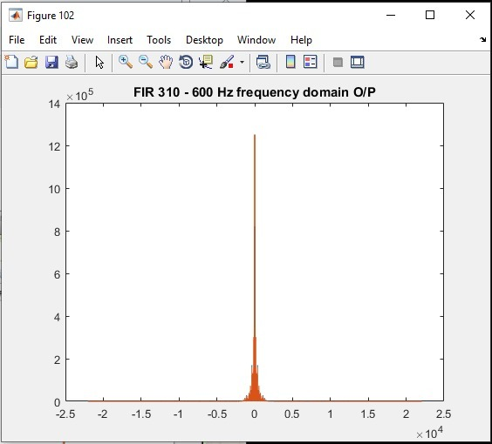

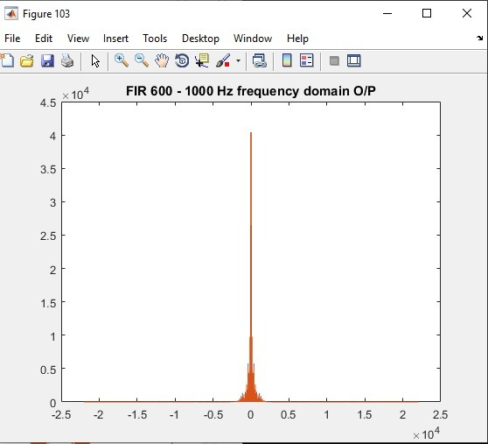

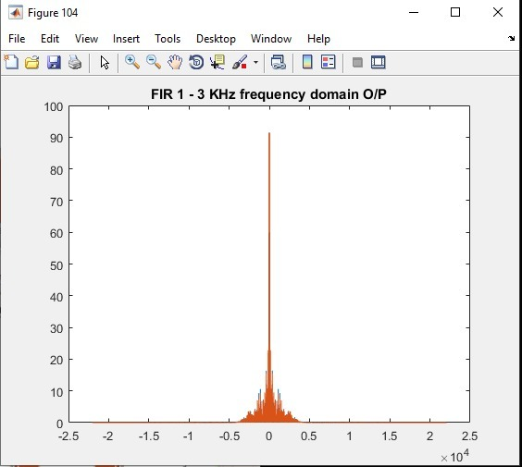

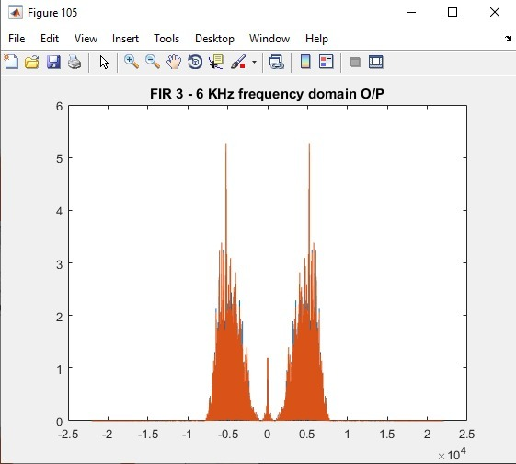

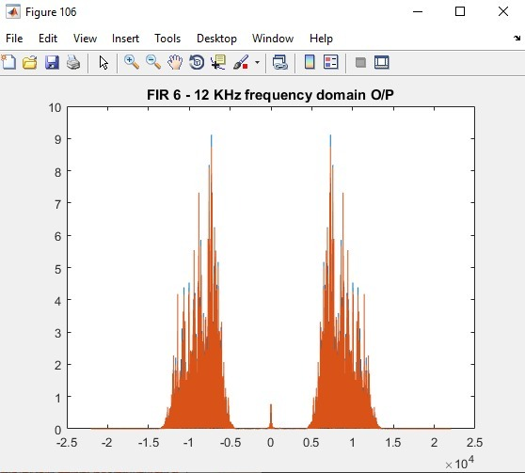

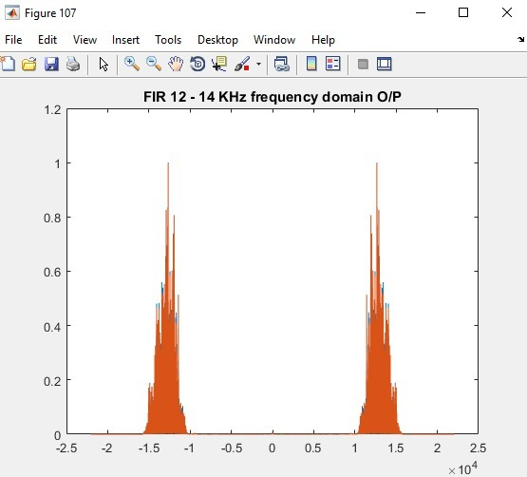

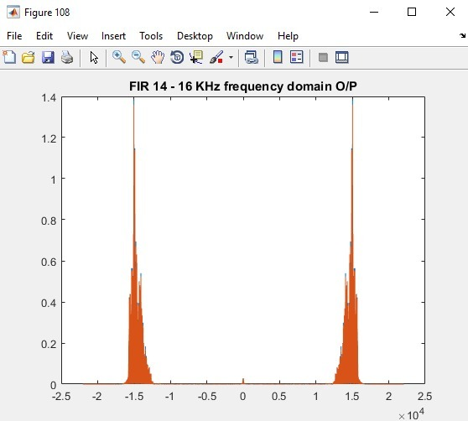

The Composite Signal in Frequency Domain

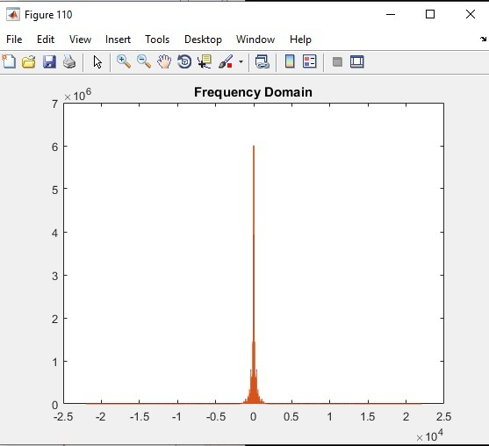

The modified composite signal with double the sampling frequency

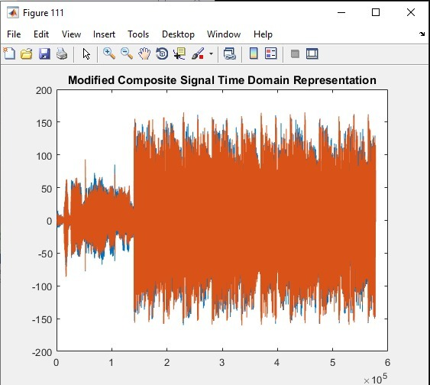

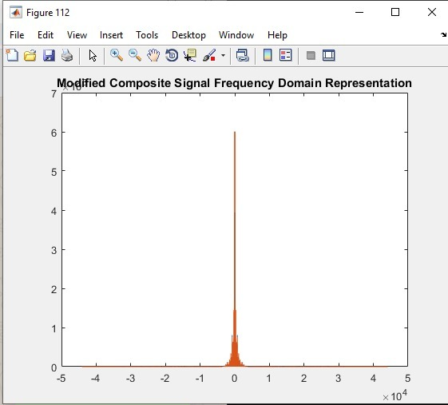

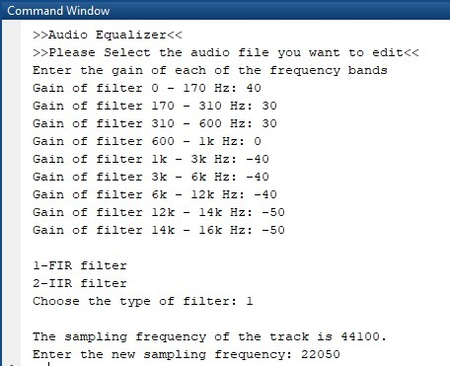



















The Composite Signal in Time Domain





















The Composite Signal in Frequency Domain



The modified composite signal with half the sampling frequency

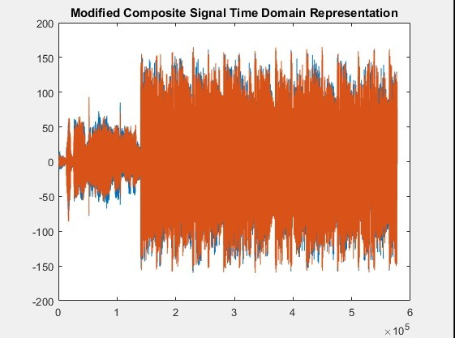

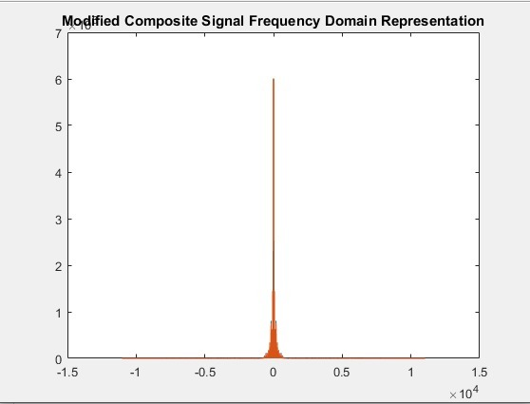

**Third Sample Run (IIR)**

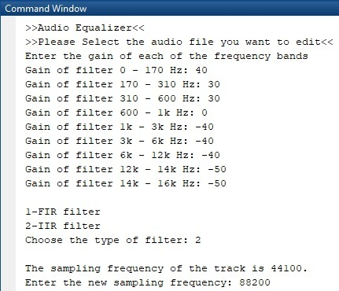

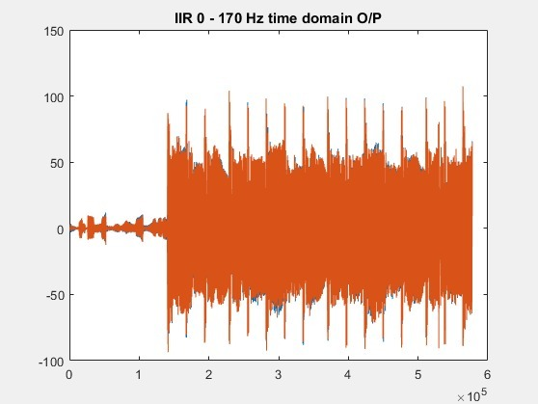

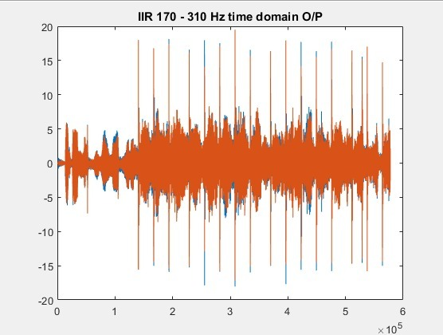

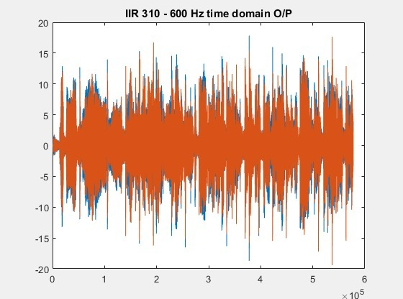

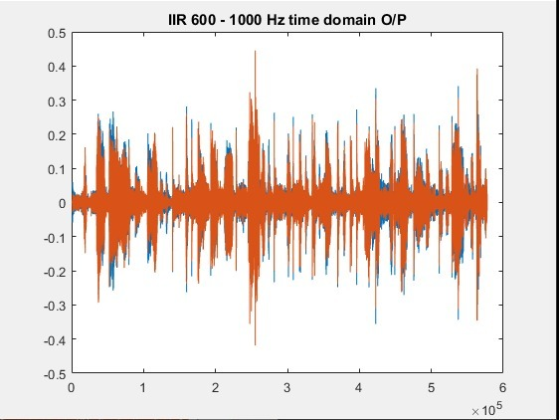

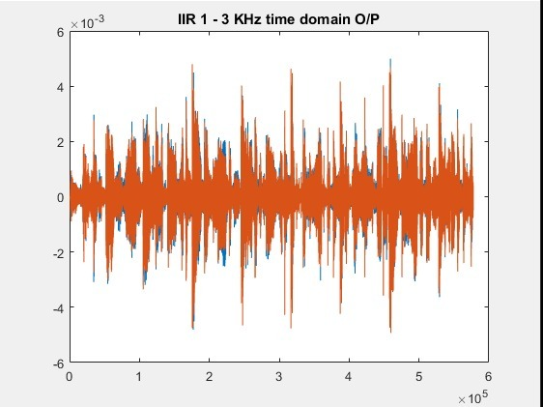

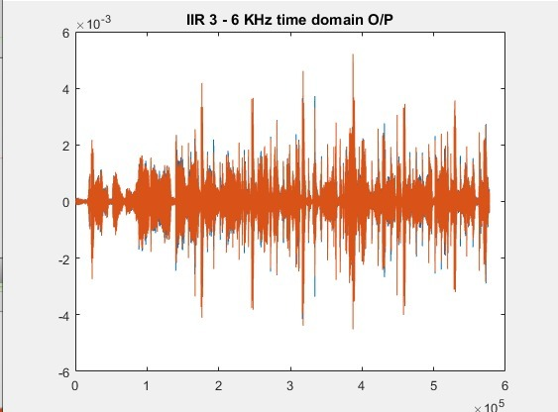

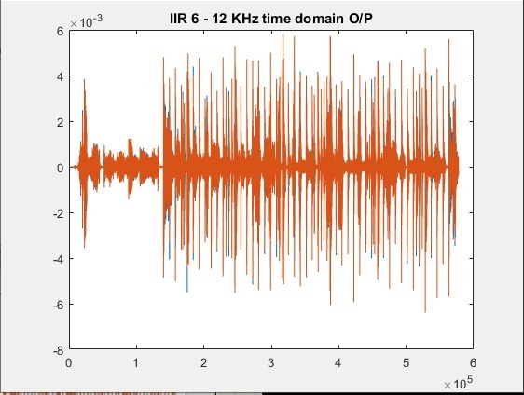

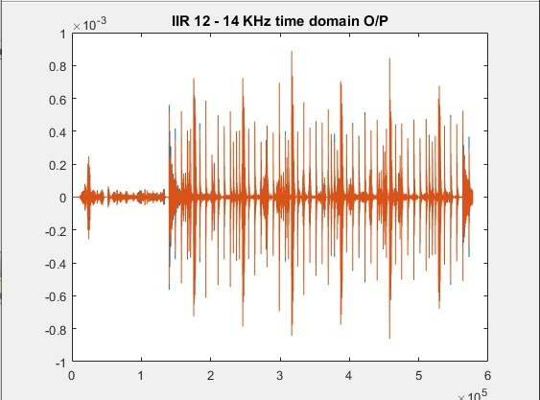

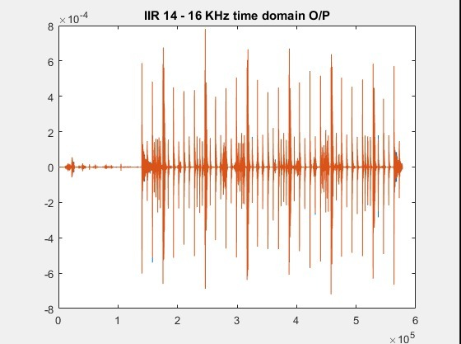

The Composite Signal in Time Domain

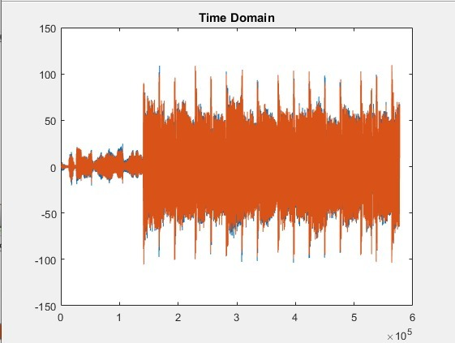

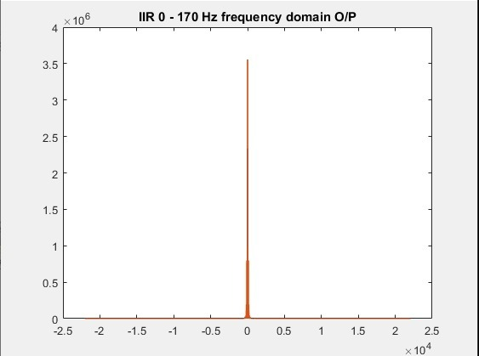

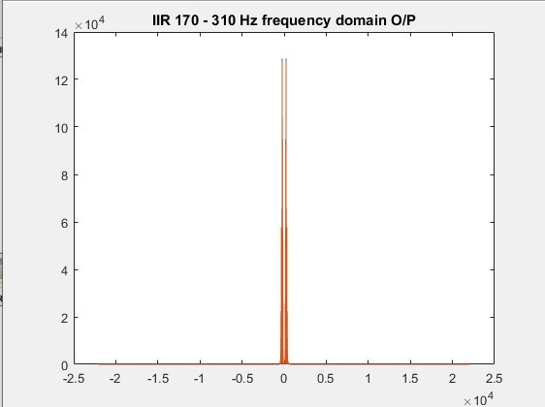

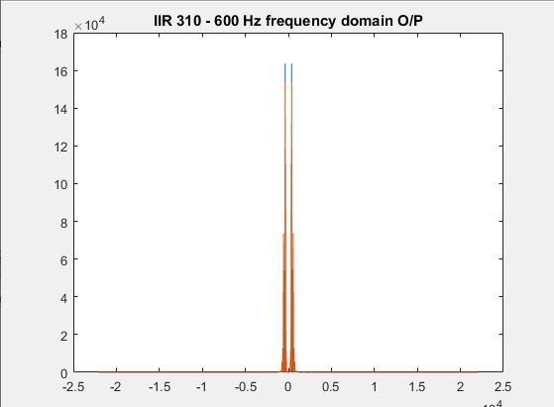

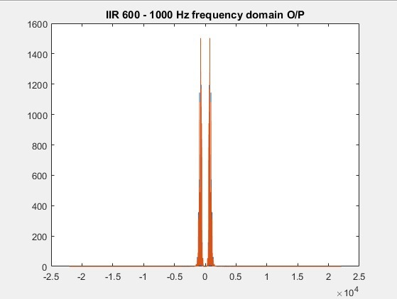

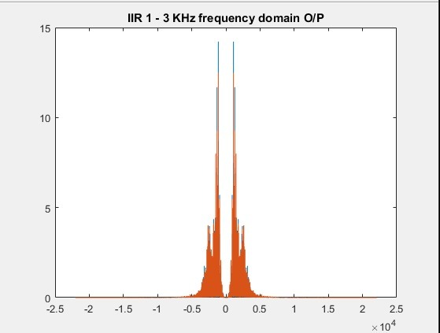

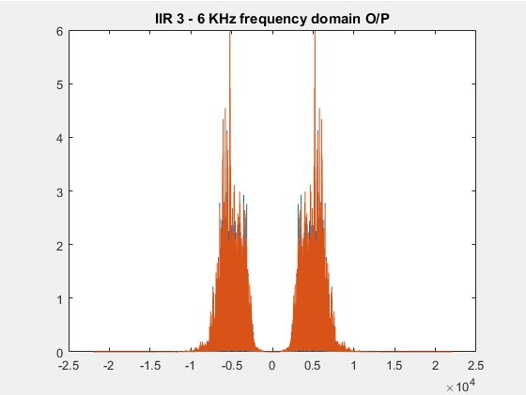

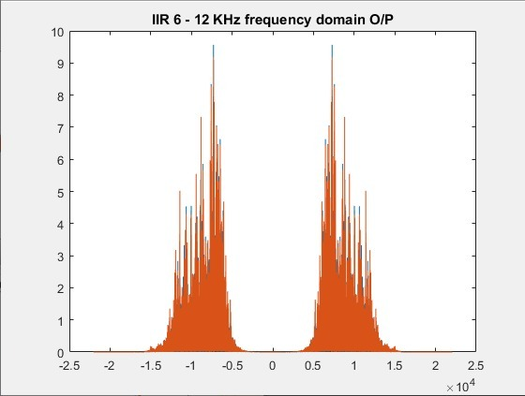

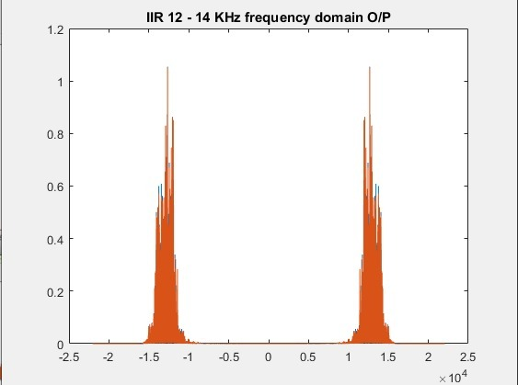

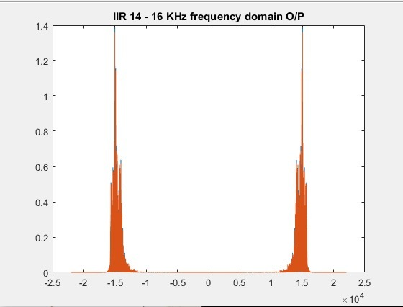

The Composite Signal in Frequency Domain

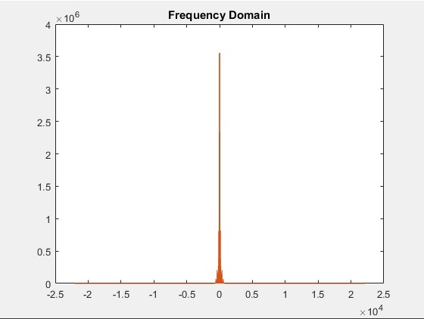

The modified composite signal with double the sampling frequency

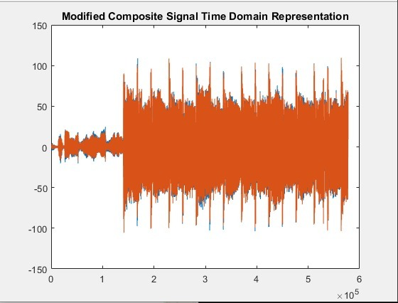

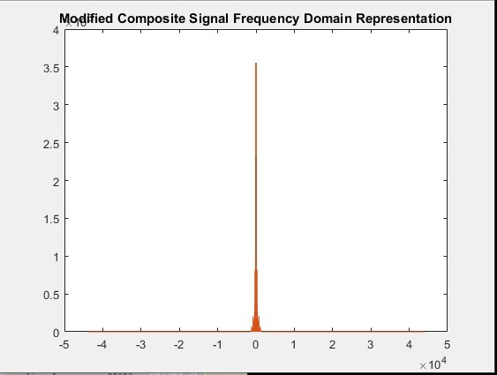

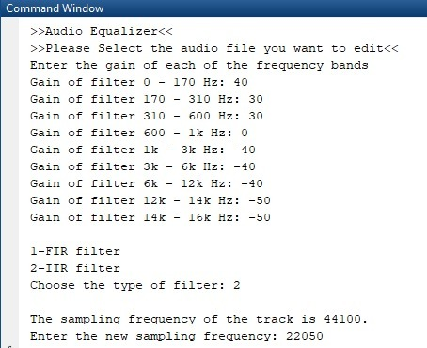



















The Composite Signal in Time Domain





















The Composite Signal in Frequency Domain



The modified composite signal with half the sampling frequency

